O sing a song of Bethlehem AMNS 413 Melody: Kingsfold D.C.M.
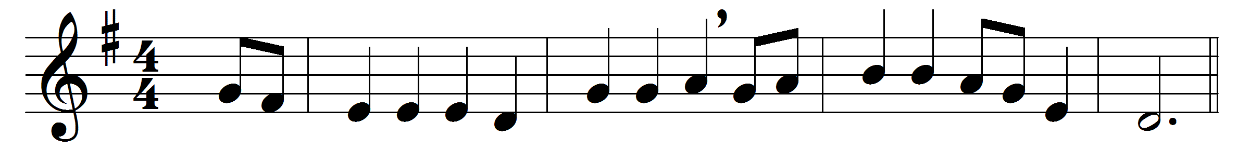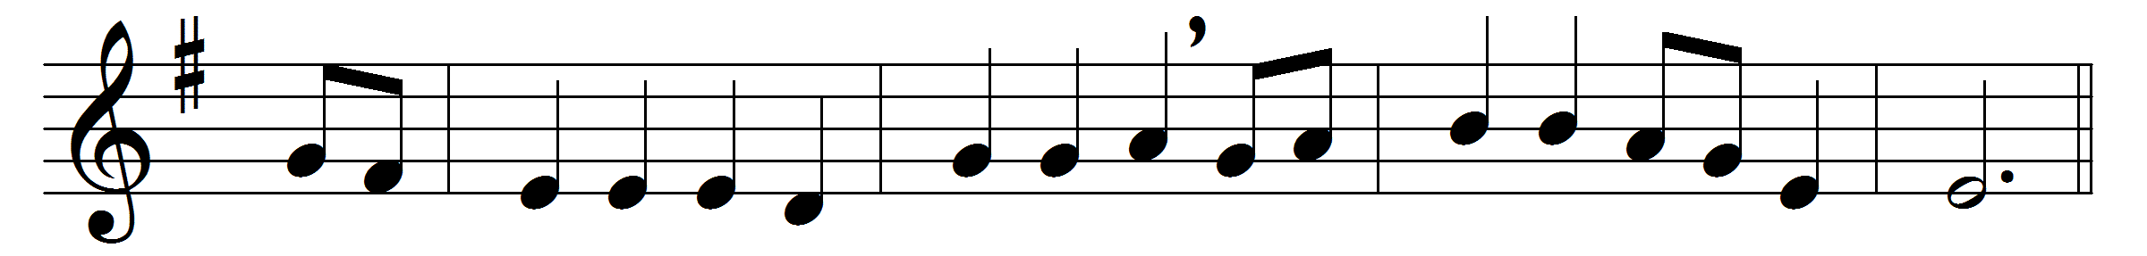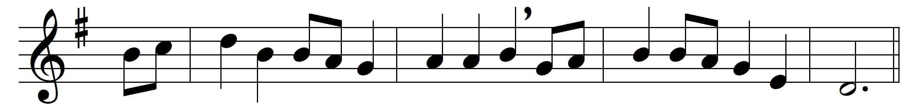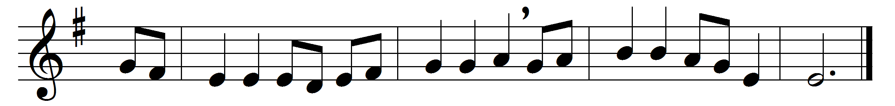

O sing a song of Bethlehem,
of shepherds watching there,
and of the news that came to them
from angels in the air:
the light that shone on Bethlehem
fills all the world today;
of Jesus’ birth and peace on earth
the angels sing alway.
O sing a song of Nazareth,
of sunny days of joy,
O sing of fragrant flowers’ breath
and of the sinless Boy:
for now the flowers of Nazareth
in every heart may grow;
now spreads the fame of his dear name
on all the winds that blow.
O sing a song of Galilee,
of lake and woods and hill,
of him who walked upon the sea
and bade its waves be still:
for though, like waves on Galilee,
dark seas of trouble roll,
when faith has heard the Master’s word,
falls peace upon the soul.
O sing a song of Calvary,
its glory and dismay;
of him who hung upon the tree,
and took our sins away:
for he who died on Calvary
is risen from the grave,
and Christ our Lord, by heaven adored,
is mighty now to save.

Words: Louis FitzGerald Benson (1855-1930)
Music: English traditional melody

