O God, whose will is life and good AMNS 408 Melody: Crucis victoria C.M.
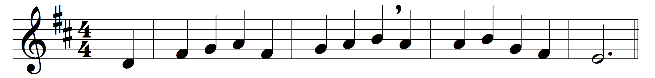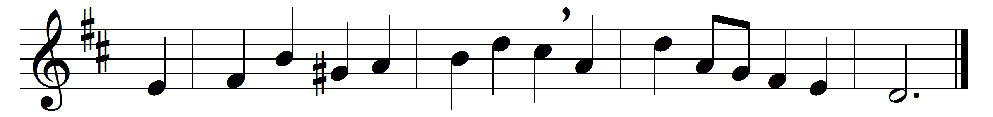

O God, whose will is life and good
for all of mortal breath,
unite in bonds of brotherhood
all those who fight with death.
Make strong their hands and hearts and wills
to drive disease afar,
to battle with the body’s ills,
and wage thy holy war.
Where’er they heal the sick and blind,
Christ’s love may they proclaim;
make known the good Physician’s mind,
and prove the Saviour’s name.
Before them set thy holy will,
that they, with heart and soul,
to thee may consecrate their skill,
and make the sufferer whole.

Words: Hardwicke Drummond Rawnsley (1851-1920)
Music: Myles Birket Foster (1851-1922)

