My Father, for another night AMNS 3 Melody: St. Timothy C.M.
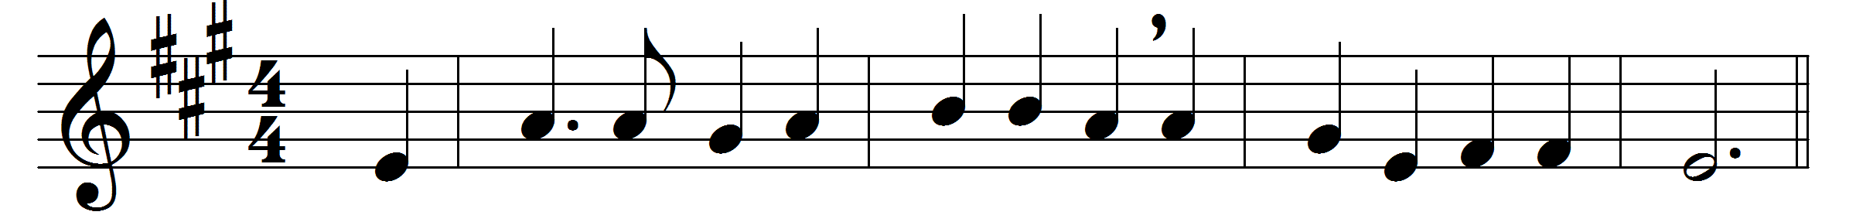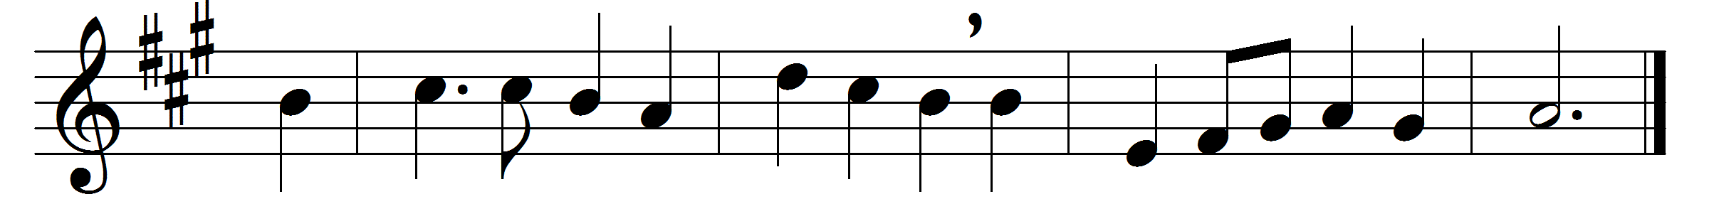

My Father, for another night
of quiet sleep and rest,
for all the joy of morning light,
thy holy name be blest.
Now with the new-born day I give
myself anew to thee,
that as thou willest I may live,
and what thou willest be.
Whate’er I do, things great or small,
whate’er I speak or frame,
thy glory may I seek in all,
do all in Jesus’ name.
My Father, for his sake, I pray,
thy child accept and bless;
and lead me by thy grace to-day
in paths of righteousness.

Words and music: Henry Williams Baker (1821-1877)

