God from on high hath heard AMNS 38 Melody: St. George S.M.

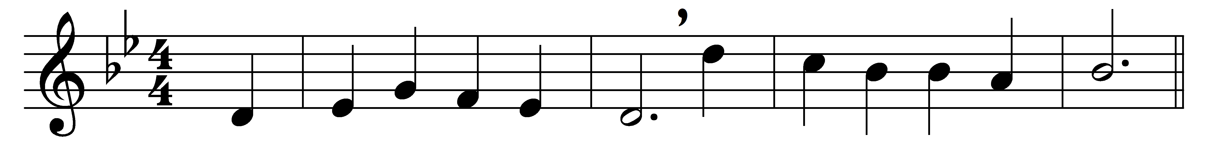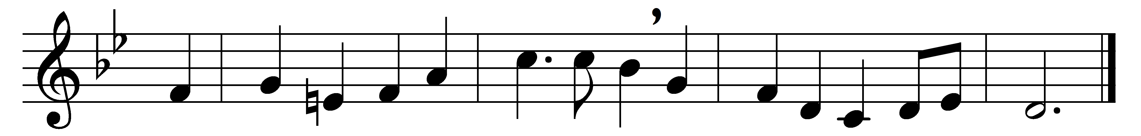

God from on high hath heard:

let sighs and sorrows cease.

Lo, from the opening heaven descends

to man the promised peace.

Hark, through the silent night

angelic voices swell;

their joyful songs proclaim that God

is born on earth to dwell.

See how the shepherd-band

speed on with eager feet;

come to the hallowed cave with them

the holy babe to greet.

But O what sight appears

within that lowly door:

a manger, stall, and swaddling clothes,

a child, and mother poor.

Art thou the Christ? the Son?

the Father’s image bright?

and see we him whose arm upholds

earth and the starry height?

Yea, faith can pierce the cloud

which veils thy glory now;

we hail thee God, before whose throne

the angels prostrate bow.

Our sinful pride to cure

with that pure love of thine,

O be thou born within our hearts,

most holy Child divine.

Words: Charles Coffin (1676-1749), translated by James Russell Woodford (1820-1885)

Music: Henry John Gauntlett (1805-1876)