Lo, in the wilderness a voice AMNS 384 Melody: Lindeman 8 7. 8 7. 8 8 7.
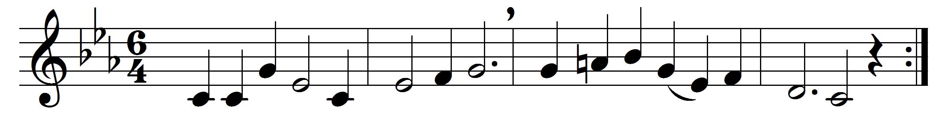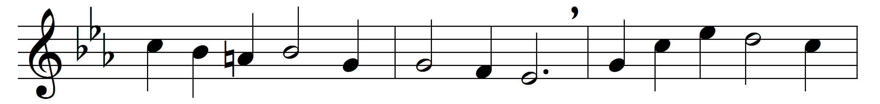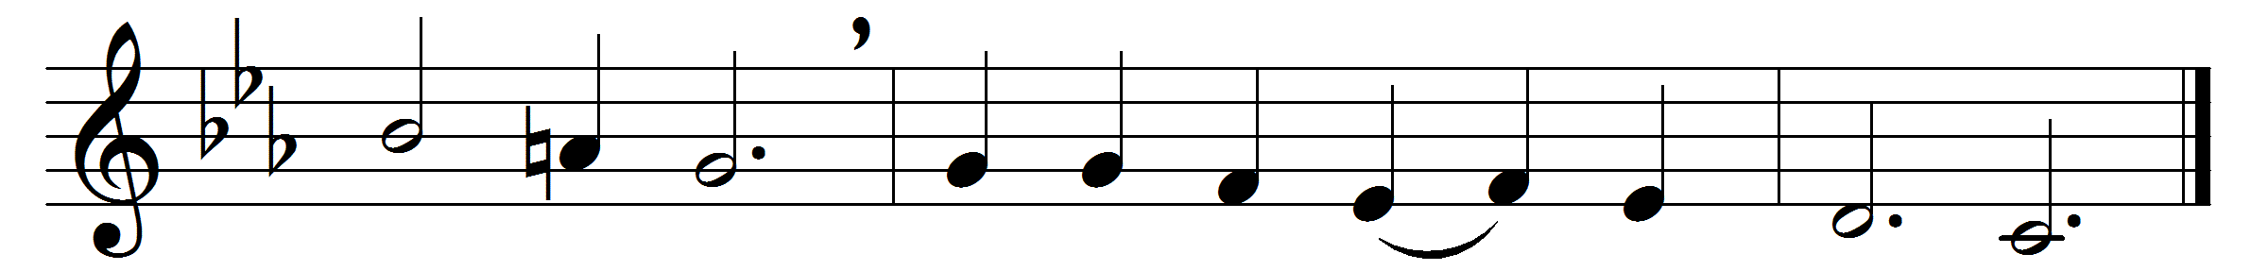

Lo, in the wilderness a voice
‘Make straight the way’ is crying:
when men are turning from the light,
and hope and love seem dying,
the prophet comes to make us clean:
‘There standeth one you have not seen,
whose voice you are denying’.
God, give us grace to hearken now
to those who come to warn us;
give sight and strength, that we may kill
the vices that have torn us;
lest love professed should disappear
in creeds of hate, contempt, and fear,
that crush and overturn us.
When from the vineyard cruel men
cast out the heavenly powers,
and Christendom denies its Lord,
the world in ruin cowers.
Now come, O God, in thy great might!
unchanged, unchanging is thy right,
unswayed thy justice towers.

Words: Percy Dearmer (1867-1936)
Music: Ludvig Matthias Lindeman (1812-1887)

