Jesus, Lord, we look to thee AMNS 380 Melody: Vienna 7 7. 7 7.
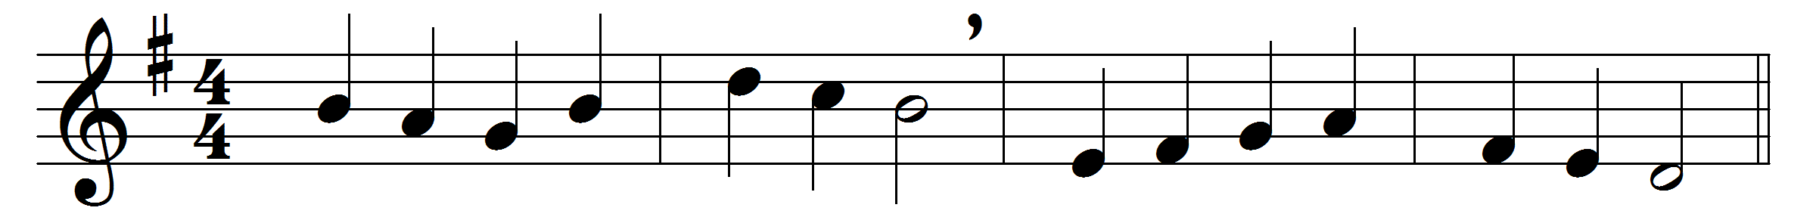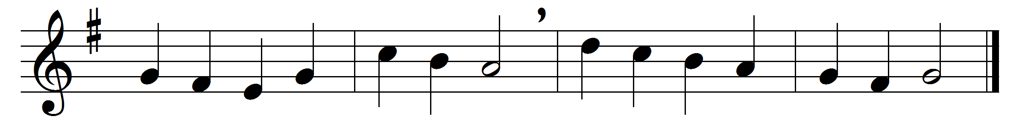

Jesus, Lord, we look to thee,
let us in thy name agree:
show thyself the Prince of Peace;
bid all strife for ever cease.

Make us of one heart and mind,
courteous, pitiful, and kind,
lowly, meek in thought and word,
altogether like our Lord.

Let us for each other care,
each the other’s burden bear;
to thy Church the pattern give,
show how true believers live.

Still our fellowship increase,
knit us in the bond of peace:
join our new-born spirits, join
each to each, and all to thine.

Free from anger and from pride,
let us thus in God abide;
all the depths of love express,
all the heights of holiness.

Words: Cento from Charles Wesley (1707-1788)
Music: Melody by Justin Heinrich Knecht (1752-1817)

