Jesus, good above all other AMNS 378 Melody: Quem pastores 8 8 8. 7.
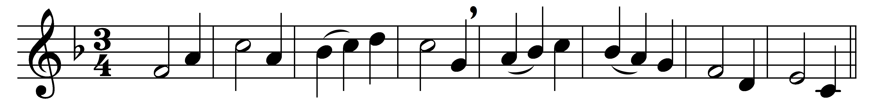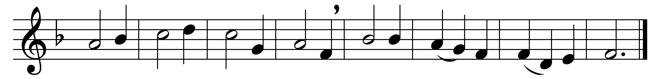

Jesus, good above all other,
gentle child of gentle mother,
in a stable born our brother,
give us grace to persevere.

Jesus, cradled in a manger,
for us facing every danger,
living as a homeless stranger,
make we thee our King most dear.

Jesus, for thy people dying,
risen Master, death defying,
Lord in heaven, thy grace supplying,
keep us to thy presence near.

Jesus, who our sorrows bearest,
all our thoughts and hopes thou sharest,
thou to man the truth declarest;
help us all thy truth to hear.

Lord, in all our doings guide us;
pride and hate shall ne’er divide us;
we’ll go on with thee beside us,
and with joy we’ll persevere.

Words: Percy Dearmer (1867-1936), partly based on John Mason Neale (1818-1866)
Music: German medieval melody

