Help us to help each other, Lord AMNS 374 Melody: Dunfermline C.M.
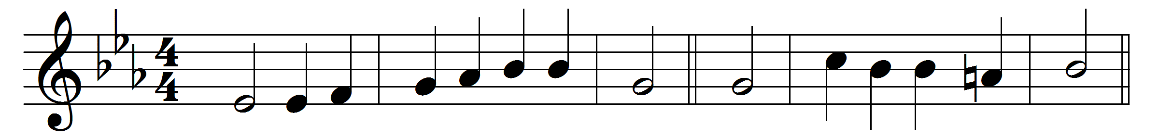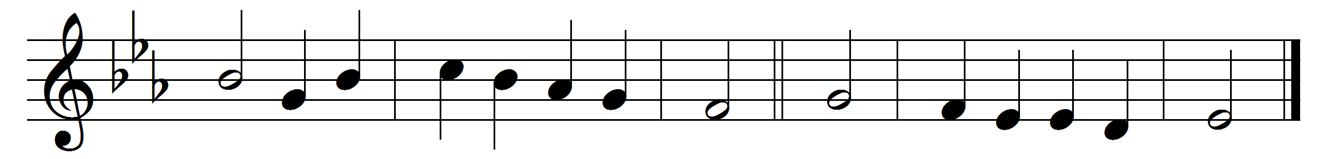

Help us to help each other, Lord,
each other’s cross to bear;
let each his friendly aid afford,
and feel his brother’s care.

Up into thee, our living head,
let us in all things grow,
and by thy sacrifice be led
the fruits of love to show.

Drawn by the magnet of thy love
let all our hearts agree;
and ever towards each other move,
and ever move towards thee.

This is the bond of perfectness,
thy spotless charity.
O let us still, we pray, possess
the mind that was in thee.

Words: Cento from Charles Wesley (1707-1788)
Music: Scottish Psalter, 1615

