As the disciples, when thy Son had left them AMNS 341 Melody: Diva servatrix 11 11 11. 5. D.
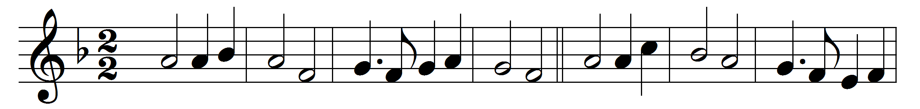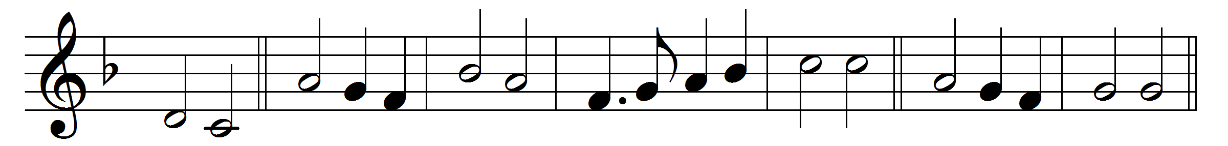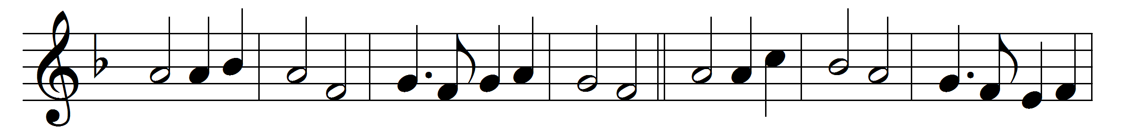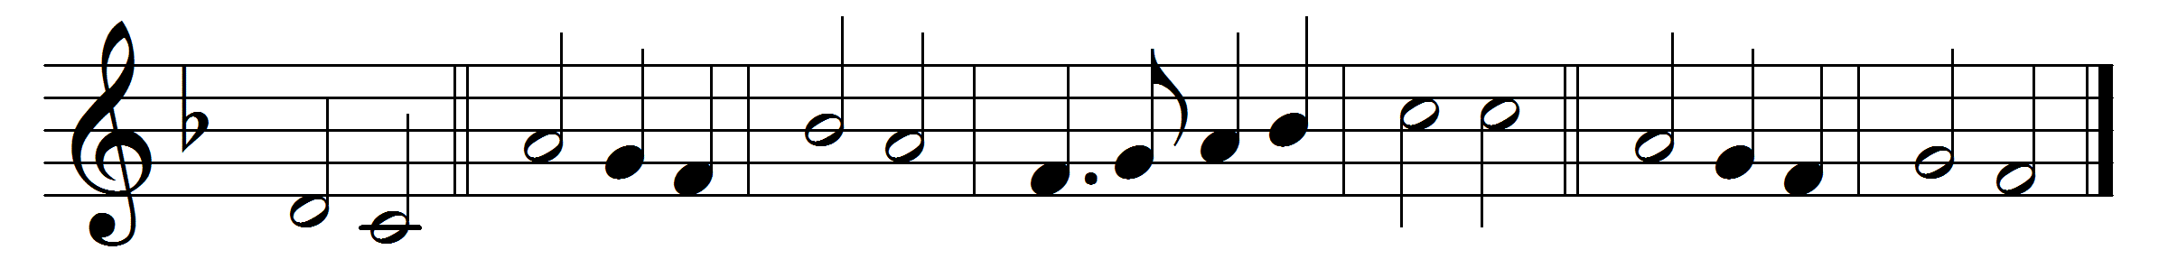

As the disciples, when thy Son had left them,
met in a love-feast, joyfully conversing,
all the stored memory of the Lord’s last supper
fondly rehearsing;
so may we here, who gather now in friendship,
seek for the spirit of those earlier Churches,
welcoming him who stands and for an entrance
patiently searches.
As, when their converse closed and supper ended,
taking the bread and wine they made thanksgiving,
breaking and blessing, thus to have communion
with Christ the living;
so may we here, a company of brothers,
make this our love-feast and commemoration,
that in his Spirit we may have more worthy
participation.
And as they prayed and sang to thee rejoicing,
ere in the night-fall they embraced and parted,
in their hearts singing as they journeyed homeward,
brave and true-hearted;
so may we here, like corn that once was scattered
over the hill-side, now one bread united,
led by the Spirit, do thy work rejoicing,
lamps filled and lighted.

Words: Percy Dearmer (1867-1936)
Music: Melody from Bayeux Antiphoner, 1739

