A stranger once did bless the earth AMNS 335 Melody: Surrey 8 8. 8 8. 8 8.
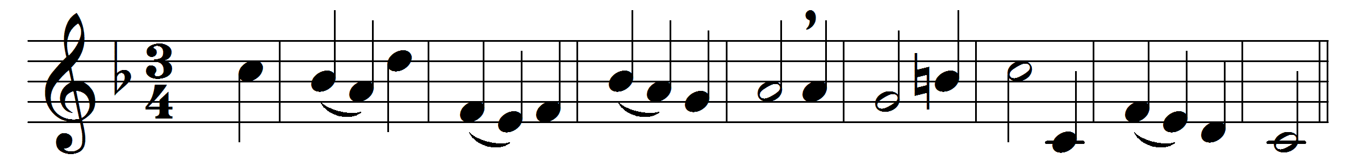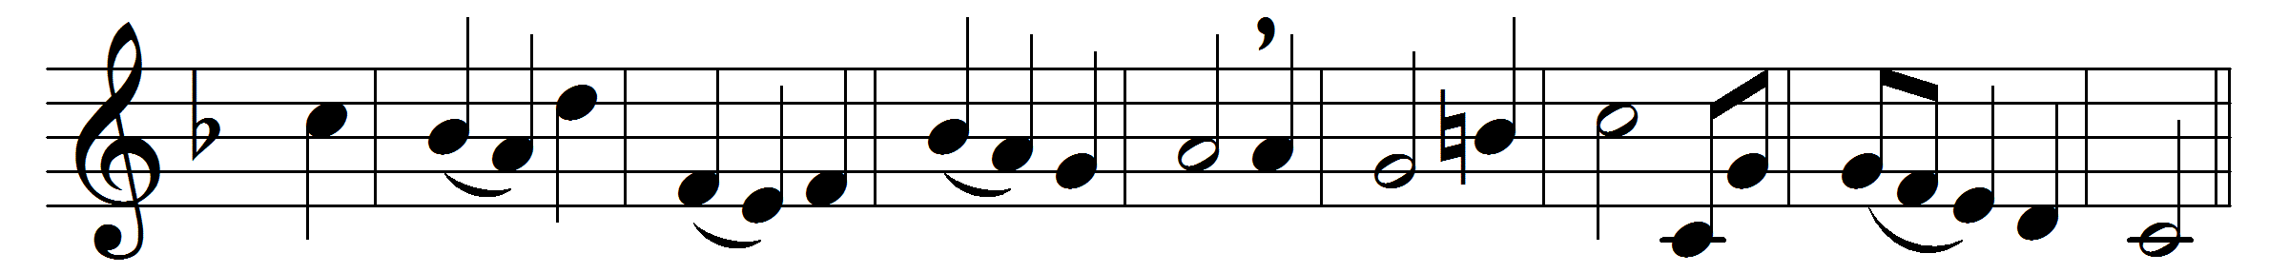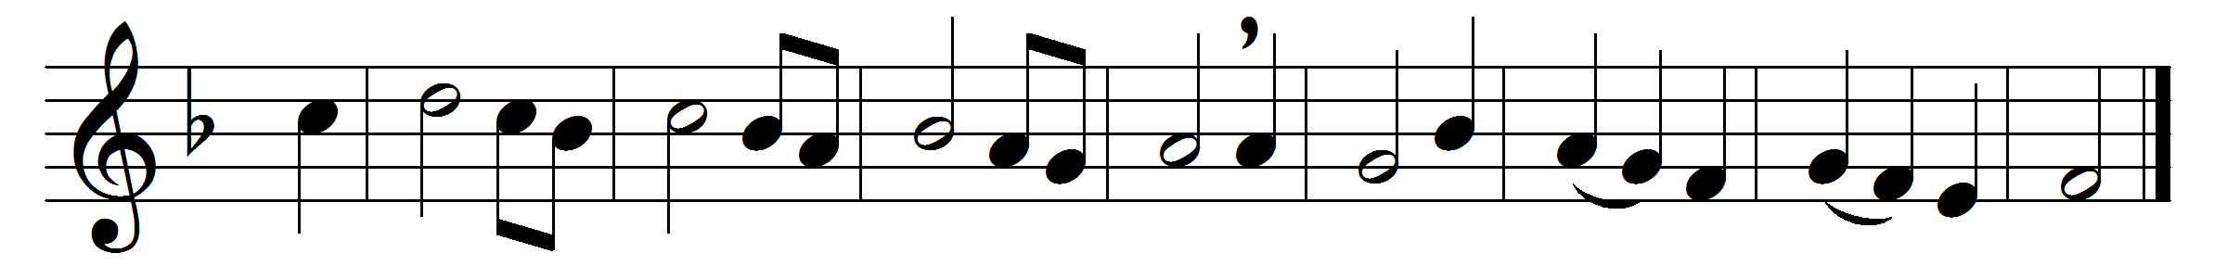

A stranger once did bless the earth
who never caused a heart to mourn,
whose very voice gave sorrow mirth;
and how did earth his worth return?
it spurned him from its lowliest lot:
the meanest station owned him not.
An outcast thrown in sorrow’s way,
a fugitive that knew no sin,
yet in lone places forced to stray;
men would not take the stranger in.
Yet peace, though much himself he mourned,
was all to others he returned.
His presence was a peace to all,
he bade the sorrowful rejoice.
Pain turned to pleasure at his call,
health lived and issued from his voice;
he healed the sick, and sent abroad
the dumb rejoicing in the Lord.
The blind met daylight in his eye,
the joys of everlasting day;
the sick found health in his reply,
the cripple threw his crutch away.
Yet he with troubles did remain,
and suffered poverty and pain.
It was for sin he suffered all
to set the world-imprisoned free,
to cheer the weary when they call;
and who could such a stranger be?
The God, who hears each human cry,
and came, a Saviour, from on high.

Words: John Clare (1793-1864)
Music: Henry Carey (c. 1690-1743)

