Blessed city, heavenly Salem AMNS 332 Melody: Oriel 8 7. 8 7. 8 7.
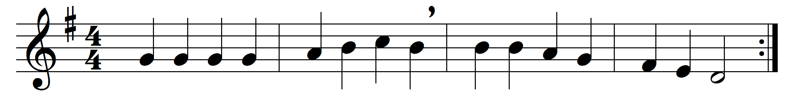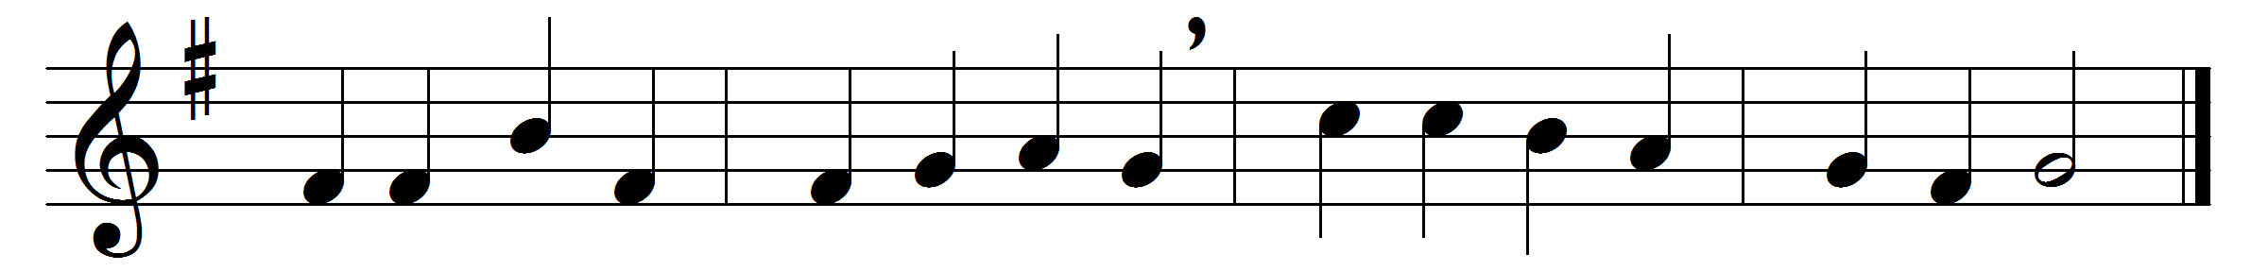

Part 1
Blessèd city, heavenly Salem,
vision dear of peace and love,
who of living stones art builded
in the height of heaven above,
and, with angel hosts encircled,
as a bride dost earthward move.

From celestial realms descending,
bridal glory round thee shed,
meet for him whose love espoused thee,
to thy Lord shalt thou be led;
all thy streets and all thy bulwarks
of pure gold are fashionèd.

Bright thy gates of pearl are shining,
they are open evermore;
and by virtue of his merits
thither faithful souls do soar,
who for Christ’s dear name in this world
pain and tribulation bore.

Many a blow and biting sculpture
polished well those stones elect,
in their places now compacted
by the heavenly Architect,
who therewith hath willed for ever
that his palace should be decked.

Part II
Christ is made the sure foundation,
Christ the head and corner-stone,
chosen of the Lord, and precious,
binding all the Church in one,
holy Sion’s help for ever,
and her confidence alone.

All that dedicated city,
dearly loved of God on high,
in exultant jubilation
pours perpetual melody,
God the One in Three adoring
in glad hymns eternally.

Part III
To this temple, where we call thee,
come, O Lord of Hosts, to-day;
with thy wonted loving-kindness
hear thy servants as they pray,
and thy fullest benediction
shed within its walls alway.

Here vouchsafe to all thy servants
what they ask of thee to gain,
what they gain from thee for ever
with the blessèd to retain,
and hereafter in thy glory
evermore with thee to reign.

Doxology
Laud and honour to the Father,
laud and honour to the Son,
laud and honour to the Spirit,
ever Three, and ever One,
consubstantial, co-eternal,
while unending ages run.

Words: Latin, 7th - 8th century, translated by John Mason Neale (1818-1866)
Music: Caspar Ett (1788-1847)

