The God of Abraham praise AMNS 331 Melody: Leoni 6 6. 8 4. D.
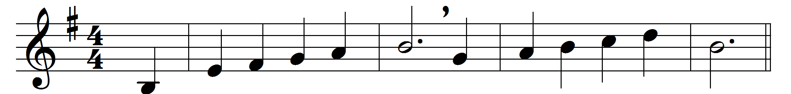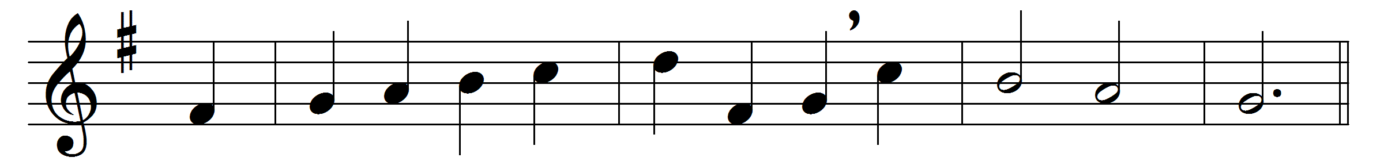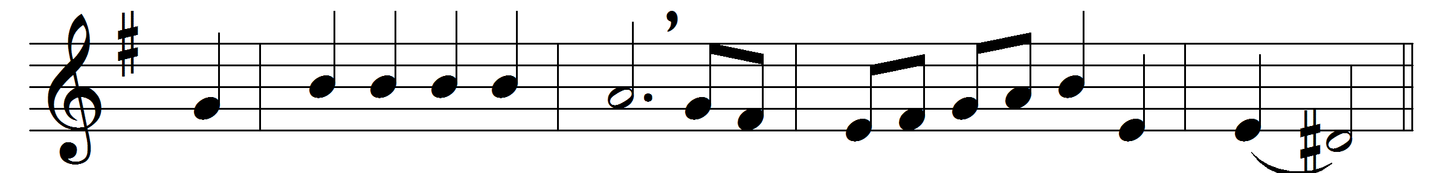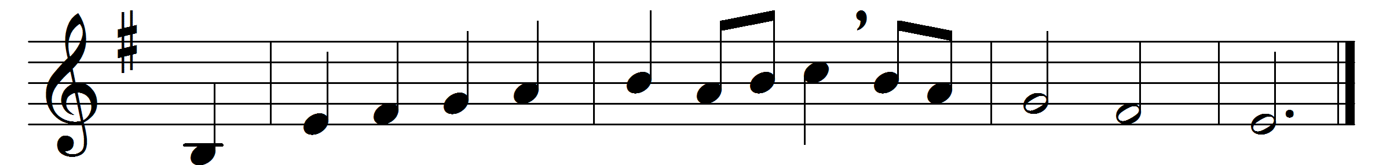

The God of Abraham praise
who reigns enthroned above,
Ancient of everlasting Days,
and God of love:
Jehovah, great I AM,
by earth and heaven confest;
we bow and bless the sacred name
for ever blest.
The God of Abraham praise,
at whose supreme command
from earth we rise, and seek the joys
at his right hand:
we all on earth forsake
its wisdom, fame, and power;
and him our only portion make,
our shield and tower.
Though nature’s strength decay,
and earth and hell withstand,
to Canaan’s bounds we urge our way
at his command:
the watery deep we pass,
with Jesus in our view;
and through the howling wilderness
our way pursue.
The goodly land we see,
with peace and plenty blest:
a land of sacred liberty
and endless rest;
there milk and honey flow,
and oil and wine abound,
and trees of life for ever grow,
with mercy crowned.
There dwells the Lord our King,
the Lord our Righteousness,
triumphant o’er the world of sin,
the Prince of peace:
on Sion’s sacred height
his kingdom he maintains,
and glorious with his saints in light
for ever reigns.
He keeps his own secure,
he guards them by his side,
arrays in garment white and pure
his spotless Bride:
with streams of sacred bliss,
beneath serener skies,
with all the fruits of Paradise,
he still supplies.
Before the great Three-One
they all exulting stand,
and tell the wonders he hath done
through all their land:
the listening spheres attend,
and swell the growing fame,
and sing in songs which never end
the wondrous name.
The God who reigns on high
the great archangels sing,
and ‘Holy, Holy, Holy,’ cry,
‘almighty King,
who was, and is the same,
and evermore shall be:
Jehovah, Father, great I AM,
we worship thee.’
Before the Saviour’s face
the ransomed nations bow,
o’erwhelmed at his almighty grace
for ever new;
he shows his prints of love –
they kindle to a flame,
and sound through all the worlds above
the slaughtered Lamb.
The whole triumphant host
give thanks to God on high;
hail, Father, Son, and Holy Ghost,
they ever cry:
hail, Abraham’s God, and mine,
(I join the heavenly lays)
all might and majesty are thine,
and endless praise.

Words: Thomas Olivers (1725-1799), based on the Hebrew Yigdal
Music: Traditional Hebrew melody

