Sleepers, wake! the watch-cry pealeth AMNS 32
Melody: Wachet auf (Sleepers, wake) 8 9 8. D. 6 6 4. 8 8.

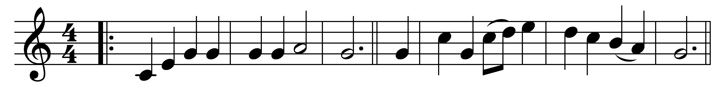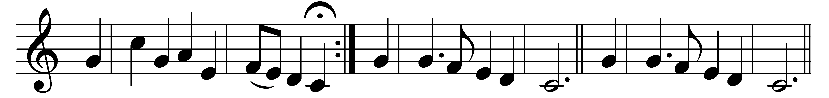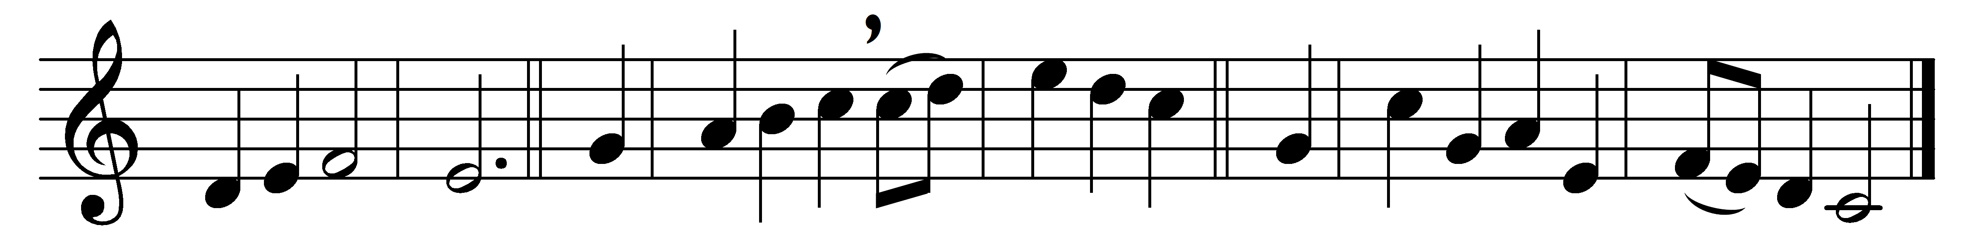

Sleepers, wake! the watch-cry pealeth,
while slumber deep each eyelid sealeth:
awake, Jerusalem, awake!
Midnight’s solemn hour is tolling,
and seraph-notes are onward rolling;
they call on us our part to take.
Come forth, ye virgins wise:
the Bridegroom comes, arise.
Alleluia!
Each lamp be bright
with ready light
to grace the marriage feast to-night.

Zion hears the voice that singeth,
with sudden joy her glad heart springeth,
at once she wakes, she stands arrayed.
See her Light, her Star ascending,
lo, girt with truth, with mercy blending,
her Bridegroom there, so long delayed.
All hail, God’s glorious Son,
all hail, our joy and crown,
Alleluia!
The joyful call
we answer all,
and follow to the bridal hall.

Praise to him who goes before us,
let men and angels join in chorus,
let harp and cymbal add their sound.
Twelve the gates, a pearl each portal –
we haste to join the choir immortal
within the Holy City’s bound.
Ear ne’er heard aught like this,
nor heart conceived such bliss.
Alleluia!
We raise the song,
we swell the throng,
to praise thee ages all along.

Words: Philipp Nicolai (1556-1608), translated by Frances Elizabeth Cox (1812-1897)
Music: Philipp Nicolai, harmony based on Bach and Mendelssohn

