Light’s glittering morn bedecks the sky AMNS 329
Melody: Lasst uns erfreuen (Easter Song) 8 8. 4 4. 8 8. and Alleluias

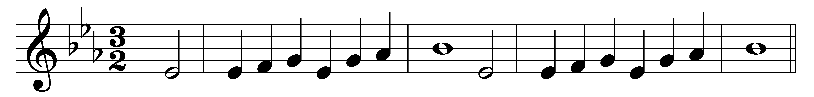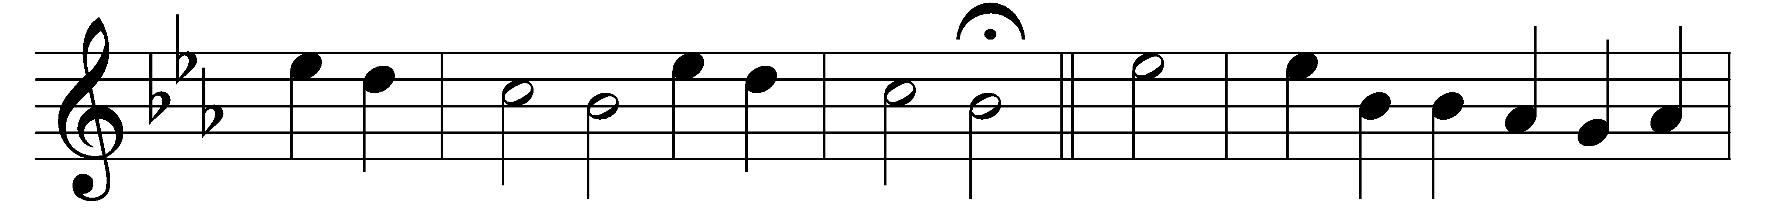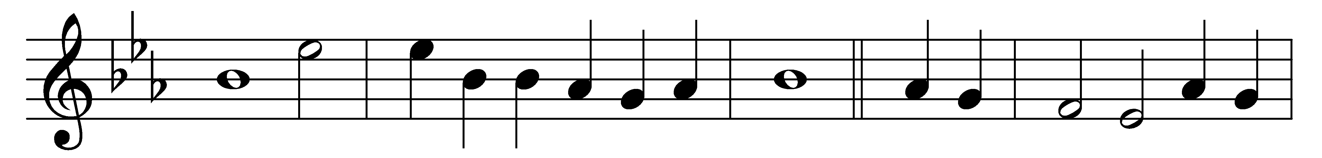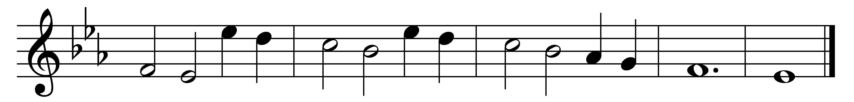

Part 1

Light’s glittering morn bedecks the sky;
heaven thunders forth its victor-cry:
Alleluia.
The glad earth shouts her triumph high,
and groaning hell makes wild reply:
Alleluia.

While he, the King, the mighty King,
despoiling death of all its sting,
and trampling down the powers of night,
brings forth his ransomed saints to light:

His tomb of late the threefold guard
of watch and stone and seal had barred;
but now, in pomp and triumph high,
he comes from death to victory:

The pains of hell are loosed at last,
the days of mourning now are past;
an angel robed in light hath said,
‘The Lord is risen from the dead:’

Part 2

O bitter the apostles’ pain
for their dear Lord so lately slain,
by rebel servants doomed to die
a death of cruel agony:

With gentle voice the angel gave
the women tidings at the grave:
‘Fear not, your Master shall ye see;
he goes before to Galilee:’

Then, hastening on their eager way
the joyful tidings to convey,
their Lord they met, their living Lord,
and falling at his feet adored:

His faithful followers with speed
to Galilee forthwith proceed,
that there once more they may behold
the Lord’s dear face, as he foretold:

Part 3

That Eastertide with joy was bright,
the sun shone out with fairer light,
when, to their longing eyes restored,
the glad apostles saw their Lord:

He bade them see his hands, his side,
where yet the glorious wounds abide;
the tokens true which made it plain
their Lord indeed was risen again:

Jesu, the King of gentleness,
do thou thyself our hearts possess,
that we may give thee all our days
the tribute of our grateful praise:

Doxology

O Lord of all, with us abide
in this our joyful Eastertide;
from every weapon death can wield
thine own redeemed for ever shield:

All praise be thine, O risen Lord,
from death to endless life restored;
all praise to God the Father be
and Holy Ghost eternally:

Words: Latin, translated by John Mason Neale (1818-1866)
Music: Melody from Geistliche Kirchengesäng, Cologne, 1623

