From the eastern mountains AMNS 327 Melody: Evelyns 6 5. 6 5. D.
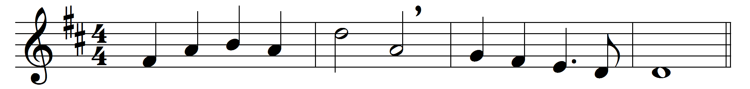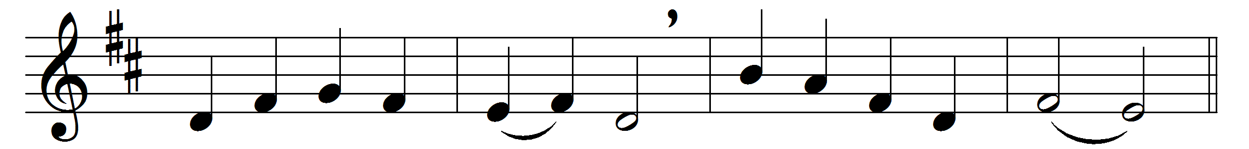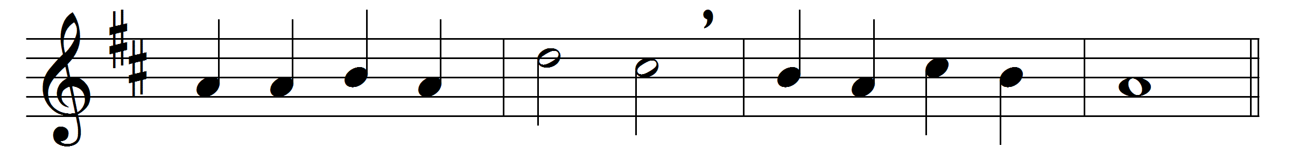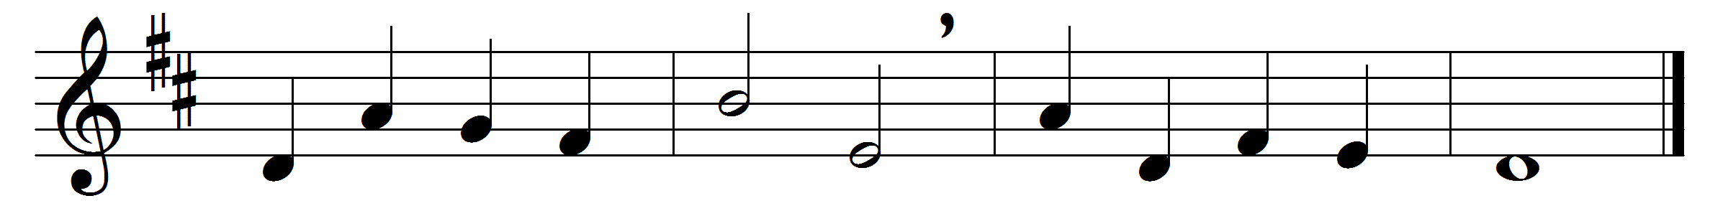

From the eastern mountains
pressing on they come,
wise men in their wisdom,
to his humble home;
stirred by deep devotion,
hasting from afar,
ever journeying onward,
guided by a star.

There their Lord and Saviour
meek and lowly lay,
wondrous light that led them
onward on their way,
ever now to lighten
nations from afar,
as they journey homeward
by that guiding star.

Thou who in a manger
once hast lowly lain,
who dost now in glory
o’er all kingdoms reign,
gather in the peoples,
who in lands afar
ne’er have seen the brightness
of thy guiding star.

Gather in the outcasts,
all who’ve gone astray;
throw thy radiance o’er them,
guide them on their way:
those who never knew thee,
those who’ve wandered far,
guide them by the brightness
of thy guiding star.

Onward through the darkness
of the lonely night,
shining still before them
with thy kindly light,
guide them, Jew and Gentile,
homeward from afar,
young and old together,
by thy guiding star.

Until every nation,
whether bond or free,
’neath thy star-lit banner,
Jesu, follow thee
o’er the distant mountains
to that heavenly home,
where nor sin nor sorrow
evermore shall come.

Words: Godfrey Thring (1823-1903)
Music: William Henry Monk (1823-1889)

