Of the Father’s love begotten AMNS 325 Melody: Corde natus (Divinum Mysterium) 8 7. 8 7. 8 7. 7.
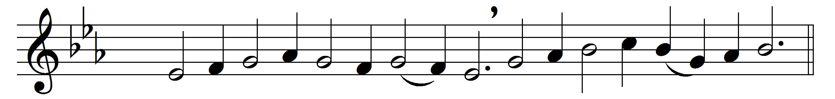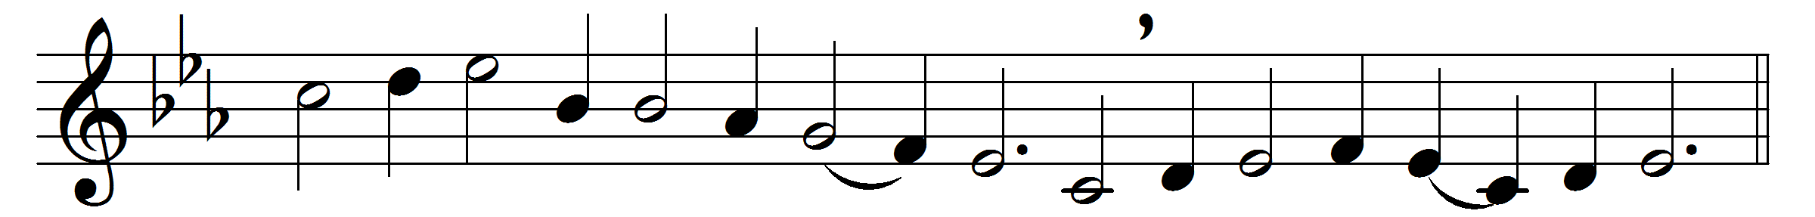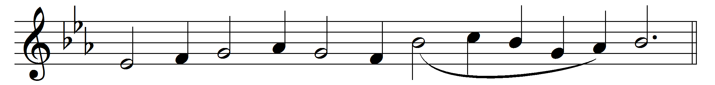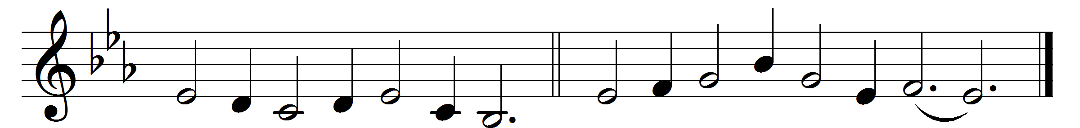

Of the Father’s love begotten
ere the worlds began to be,
he is Alpha and Omega,
he the source, the ending he,
of the things that are, that have been,
and that future years shall see,
evermore and evermore.

At his word they were created;
he commanded; it was done:
heaven and earth and depths of ocean
in their threefold order one;
all that grows beneath the shining
of the light of moon and sun,
evermore and evermore.

O that birth for ever blessèd
when the Virgin, full of grace,
by the Holy Ghost conceiving,
bare the Saviour of our race,
and the Babe, the world’s Redeemer,
first revealed his sacred face,
evermore and evermore.

O ye heights of heaven, adore him;
angel-hosts, his praises sing;
powers, dominions, bow before him,
and extol our God and King:
let no tongue on earth be silent,
every voice in concert ring,
evermore and evermore.

This is he whom seers and sages
sang of old with one accord;
whom the writings of the prophets
promised in their faithful word;
now he shines, the long-expected:
let creation praise its Lord,
evermore and evermore.

Hail, thou Judge of souls departed!
hail, thou King of them that live!
on the Father’s throne exalted
none in might with thee may strive;
who at last in judgement coming
sinners from thy face shalt drive,
evermore and evermore.

Now let old and young men’s voices
join with boys’ thy name to sing,
matrons, virgins, little maidens
in glad chorus answering;
let their guileless songs re-echo,
and the heart its praises bring,
evermore and evermore.

Christ, to thee, with God the Father,
and, O Holy Ghost, to thee,
hymn and chant and high thanksgiving
and unwearied praises be,
honour, glory, and dominion,
and eternal victory,
evermore and evermore.

Words: Prudentius (348-c. 413), translated by John Mason Neale (1818-1866), Henry Williams Baker (1821-1877) and others
Music: Later form of plainsong melody, as in Piae Cantiones, 1582

