Who are these like stars appearing AMNS 323 Melody: All Saints 8 7. 8 7. 7 7.
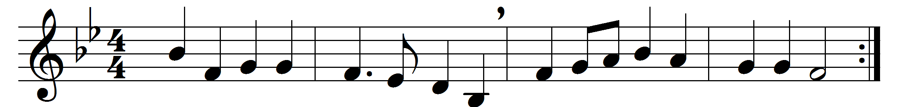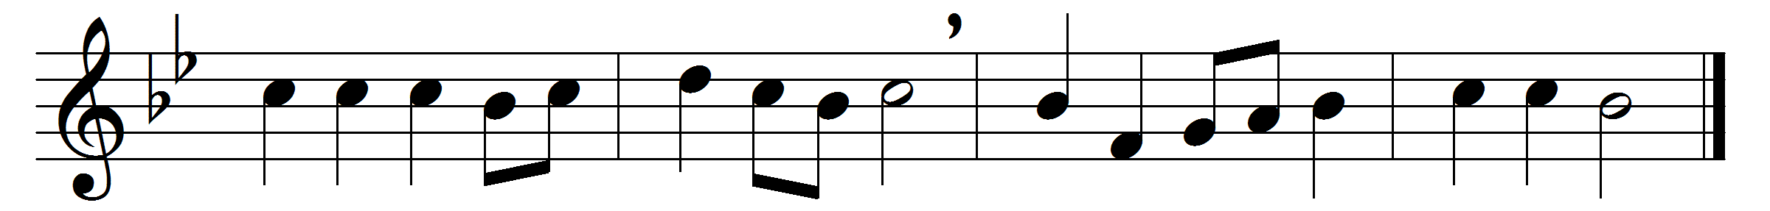

Who are these like stars appearing,
these, before God’s throne who stand?
each a golden crown is wearing:
who are all this glorious band?
Alleluia, hark, they sing,
praising loud their heavenly King.
Who are these in dazzling brightness,
clothed in God’s own righteousness,
these, whose robes of purest whiteness
shall their lustre still possess,
still untouched by time’s rude hand?
whence came all this glorious band?
These are they who have contended
for their Saviour’s honour long,
wrestling on till life was ended,
following not the sinful throng;
these, who well the fight sustained,
triumph by the Lamb have gained.
These are they whose hearts were riven,
sore with woe and anguish tried,
who in prayer full oft have striven
with the God they glorified;
now, their painful conflict o’er,
God has bid them weep no more.
These, the Almighty contemplating,
did as priests before him stand,
soul and body always waiting
day and night at his command:
now in God’s most holy place
blest they stand before his face.

Words: Heinrich Theobald Schenck (1656-1727), translated by Frances Elizabeth Cox (1812-1897)
Music: From Geistreiches Gesangbuch (1698), adapted by William Henry Monk (1823-1889)

