O heavenly Jerusalem AMNS 322 Melody: St. Alphege 7 6. 7 6.
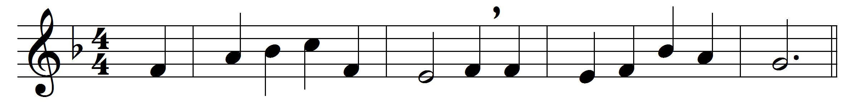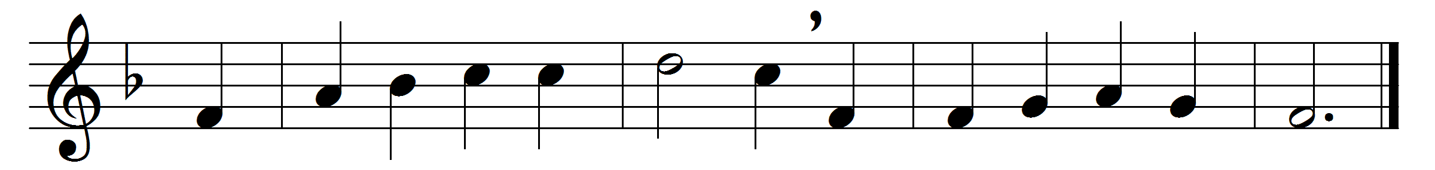

O heavenly Jerusalem
of everlasting halls,
thrice blessèd are the people
thou storest in thy walls.
Thou art the golden mansion
where saints for ever sing,
the seat of God’s own chosen,
the palace of the King.
There God for ever sitteth,
himself of all the crown:
the Lamb, the light that shineth
and never goeth down.
Naught to this seat approacheth
their sweet peace to molest;
they sing their God for ever,
nor day nor night they rest.
Sure hope doth thither lead us;
our longings thither tend:
may short-lived toil ne’er daunt us
for joys that cannot end.
To Christ the sun that lightens
his Church above, below,
to Father, and to Spirit,
all things created bow.

Words: Latin, 18th century, translated by Isaac Williams (1802-1865)
Music: Henry John Gauntlett (1805-1876)

