Christ, the fair glory of the holy angels AMNS 321 Melody: Coelites Plaudant (Rouen) 11 11 11. 5.
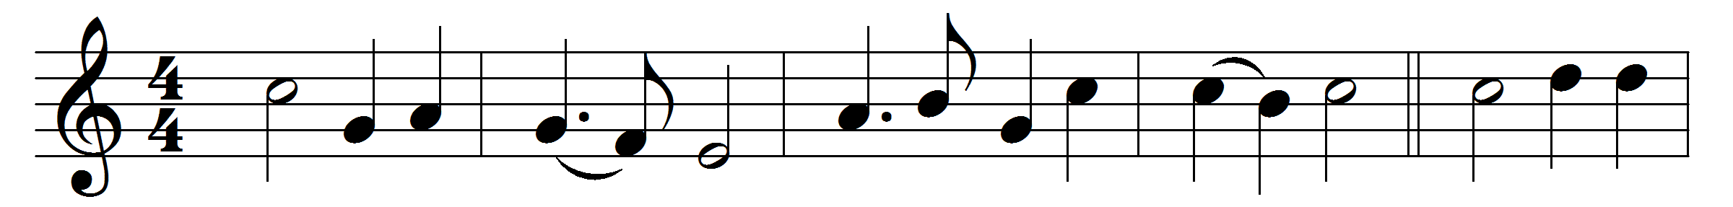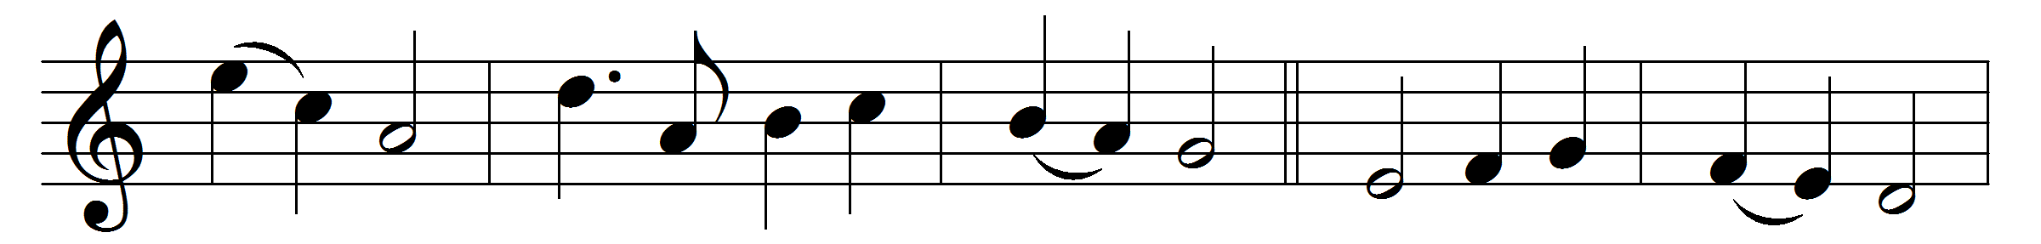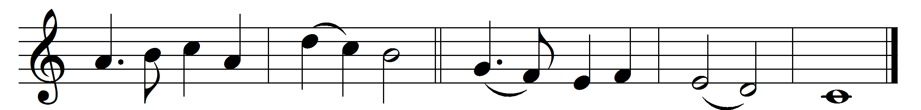

Christ, the fair glory of the holy angels,
ruler of all men, author of creation,
grant us in mercy grace to win by patience
joys everlasting.
Send thine archangel Michael from thy presence:
peacemaker blessèd, may he hover o’er us,
hallow our dwellings, that for us thy children
all things may prosper.
Send thine archangel, Gabriel the mighty:
on strong wings flying, may he come from heaven,
drive from thy temple Satan the old foeman,
succour our weakness.
Send thine archangel, Raphael the healer:
through him with wholesome med’cines of salvation
heal our backsliding, and in paths of goodness
guide our steps daily.
Father almighty, Son, and Holy Spirit,
Godhead eternal, grant us our petition;
thine be the glory through the whole creation
now and for ever.
Words: Ascribed to Rabanus Maurus (776-856), translated by Charles Stanley Phillips (1883-1949)
Music: Melody from Rouen Antiphoner, 1728

