’Tis good, Lord, to be here AMNS 318 Melody: Carlisle S.M.
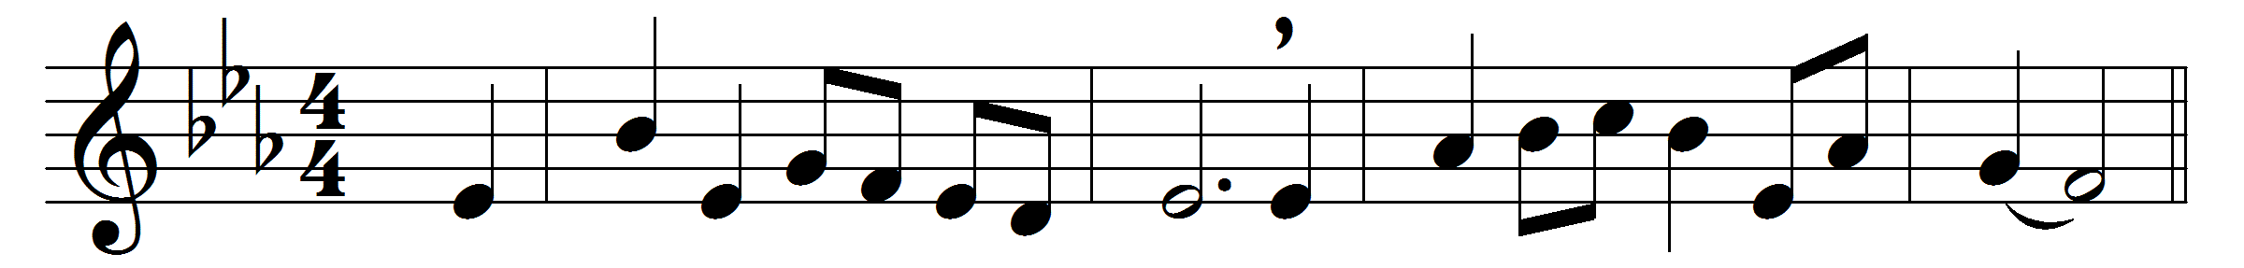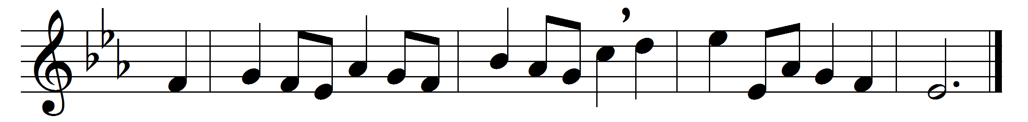

’Tis good, Lord, to be here,
thy glory fills the night;
thy face and garments, like the sun,
shine with unborrowed light.
’Tis good, Lord, to be here,
thy beauty to behold,
where Moses and Elijah stand,
thy messengers of old.
Fulfiller of the past,
promise of things to be,
we hail thy body glorified,
and our redemption see.
Before we taste of death,
we see thy kingdom come;
we fain would hold the vision bright,
and make this hill our home.
’Tis good, Lord, to be here,
yet we may not remain;
but since thou bidst us leave the mount,
come with us to the plain.

Words: Joseph Armitage Robinson (1858-1933)
Music: Charles Lockhart (1745-1815)

