Sing we the praises of the great forerunner AMNS 315 Melody: Lobet den Herren 11 11 11. 5.
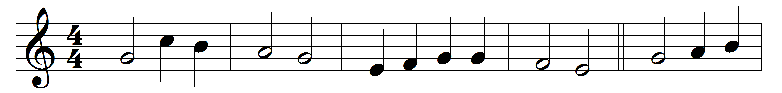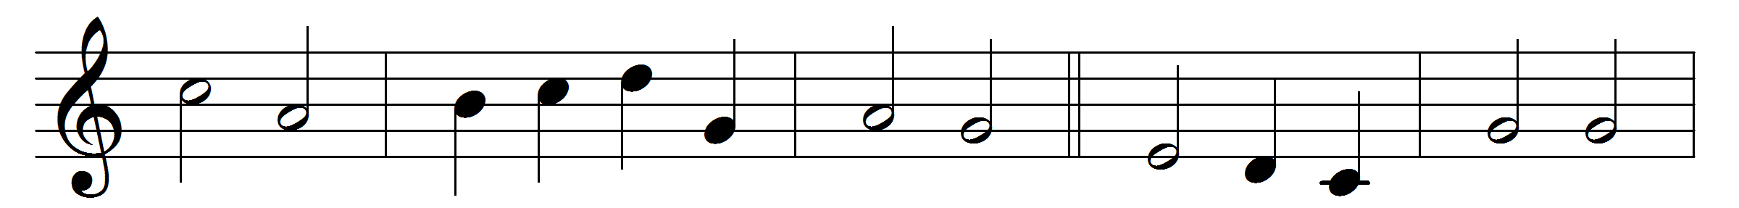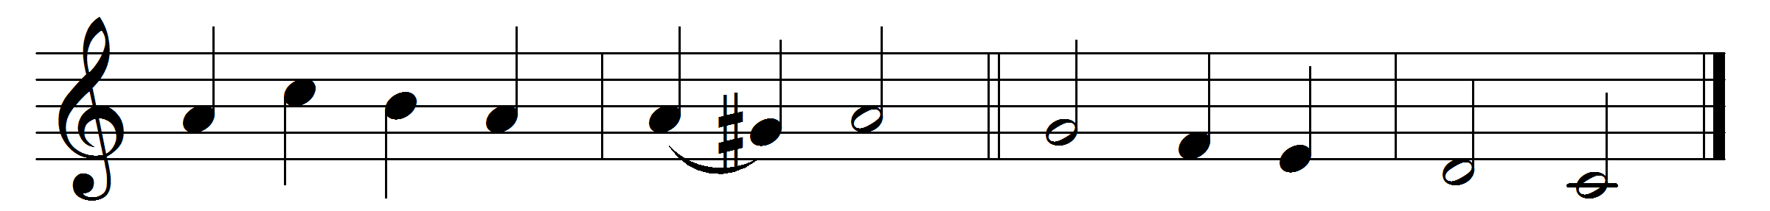

Sing we the praises of the great forerunner,
tell forth the mighty wonders of his story:
so may his Master cleanse our lips and make them
fit to extol him.
Lo, God’s high herald, swift from heaven descending,
gives to thy father tidings of thy coming,
telling thy name and all the tale of marvels
that shall befall thee.
Oft had the prophets in the time before thee
spoken in vision of the Daystar’s coming;
but when he came, ’twas thou that didst proclaim him
Saviour of all men.

Words: Paul the Deacon (730-799), translated by Charles Stanley Phillips (1883-1949)
Music: Melody by Johann Crüger (1598-1662)

