Hail to the Lord who comes AMNS 314 Melody: Old 120th 6 6. 6 6. 6 6.
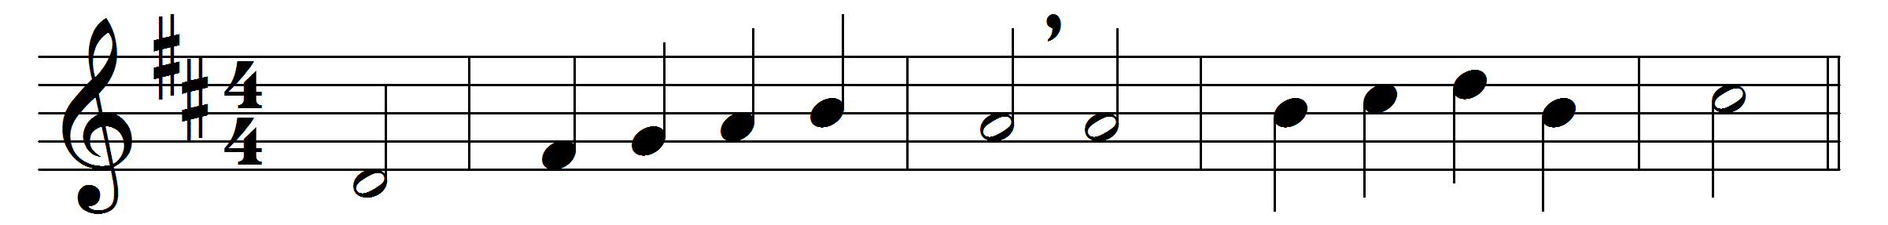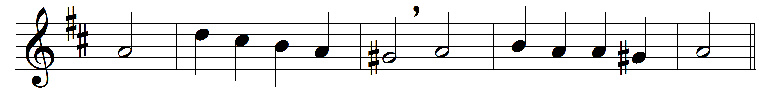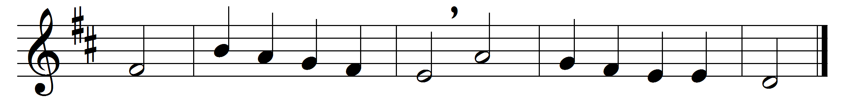

Hail to the Lord who comes,
comes to his temple gate,
not with his angel host,
not in his kingly state:
no shouts proclaim him nigh,
no crowds his coming wait.

But borne upon the throne
of Mary’s gentle breast,
watched by her duteous love,
in her fond arms at rest;
thus to his Father’s house
he comes, the heavenly guest.

There Joseph at her side
in reverent wonder stands;
and, filled with holy joy,
old Simeon in his hands
takes up the promised Child,
the glory of all lands.

Hail to the great First-born,
whose ransom-price they pay,
the Son before all worlds,
the Child of man to-day,
that he might ransom us
who still in bondage lay.

O Light of all the earth,
thy children wait for thee:
come to thy temples here,
that we, from sin set free,
before thy Father’s face
may all presented be.

Words: John Ellerton (1826-1893)
Music: Melody from Psalms, 1570

