Jesus calls us: o’er the tumult AMNS 312 Melody: St. Andrew 8 7. 8 7.
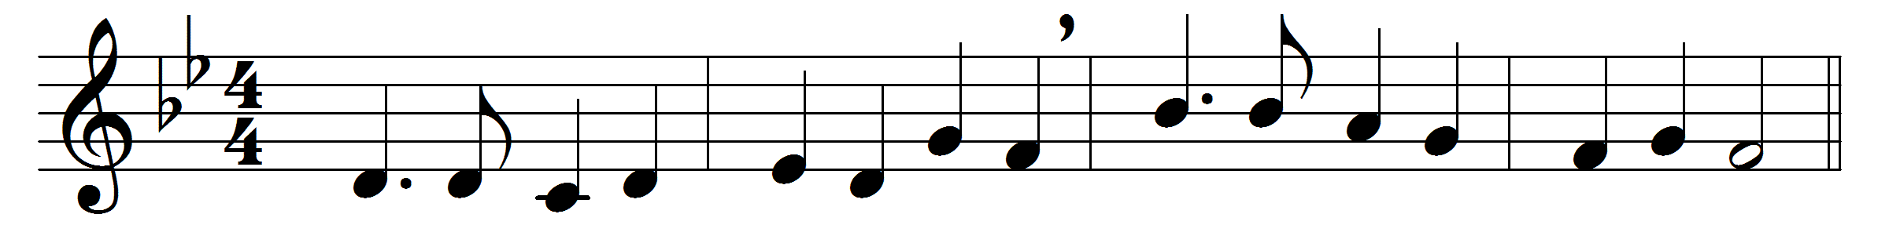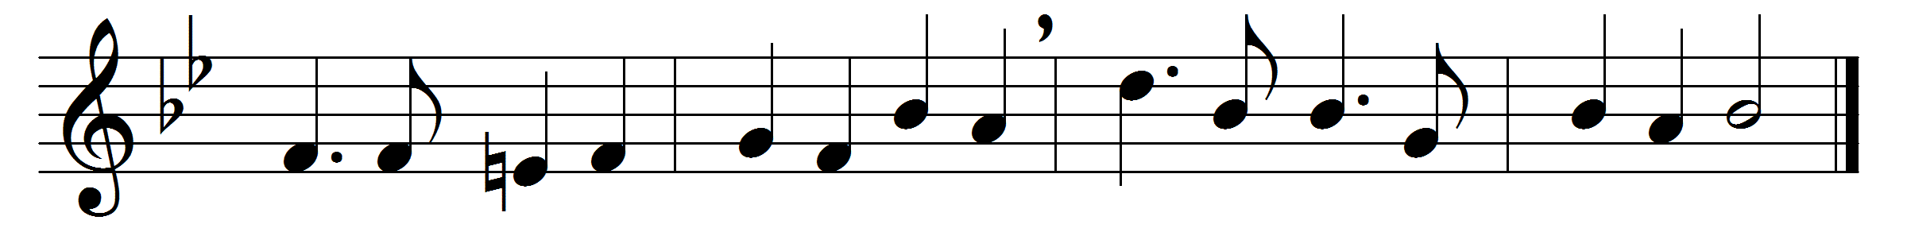

Jesus calls us: o’er the tumult
of our life’s wild restless sea
day by day his sweet voice soundeth,
saying, ‘Christian, follow me;’
as of old Saint Andrew heard it
by the Galilean lake,
turned from home and toil and kindred,
leaving all for his dear sake.

Jesus calls us from the worship
of the vain world’s golden store,
from each idol that would keep us,
saying, ‘Christian, love me more.’
In our joys and in our sorrows,
days of toil and hours of ease,
still he calls, in cares and pleasures,
that we love him more than these.
Jesus calls us: by thy mercies,
Saviour, make us hear thy call,
give our hearts to thine obedience,
serve and love thee best of all.

Words: Cecil Frances Alexander (1818-1895)
Music: Edward Henry Thorne (1834-1916)

