Virgin-born, we bow before thee AMNS 311 Melody: Quem pastores 8 8 8. 7.
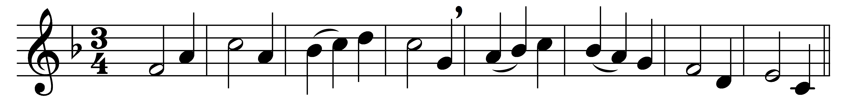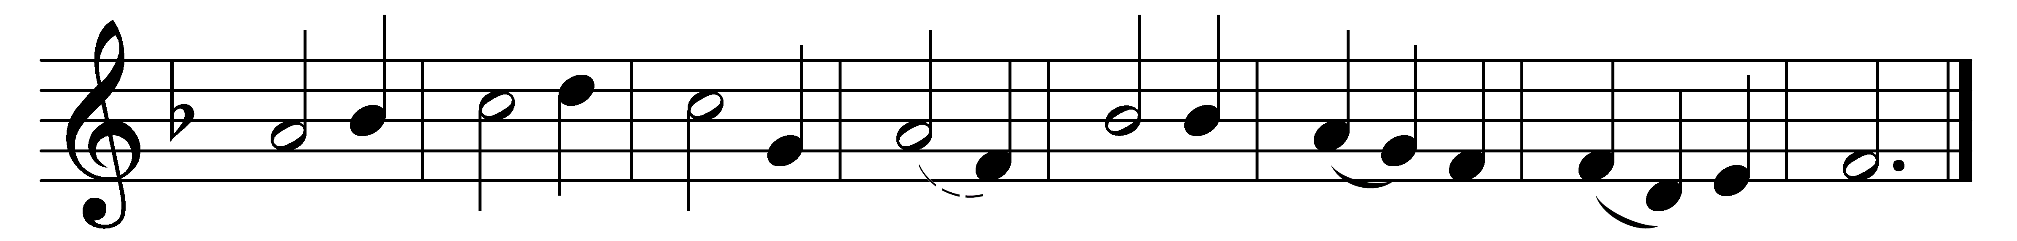

Virgin-born, we bow before thee:
blessèd was the womb that bore thee;
Mary, maid and mother mild,
blessèd was she in her child.

Blessèd was the breast that fed thee;
blessèd was the hand that led thee;
blessèd was the parent’s eye
that watched thy slumbering infancy.

Blessèd she by all creation,
who brought forth the world’s Salvation;
blessèd they, for ever blest,
who love thee most and serve thee best.

Virgin-born, we bow before thee:
blessèd was the womb that bore thee;
Mary, maid and mother mild,
blessèd was she in her child.

Words: Reginald Heber (1783-1826)
Music: German medieval melody

