Her Virgin eyes saw God incarnate born AMNS 310 Melody: Farley Castle 10 10. 10 10.
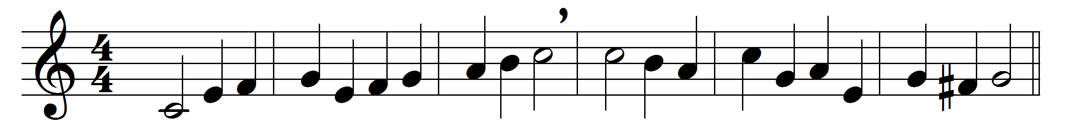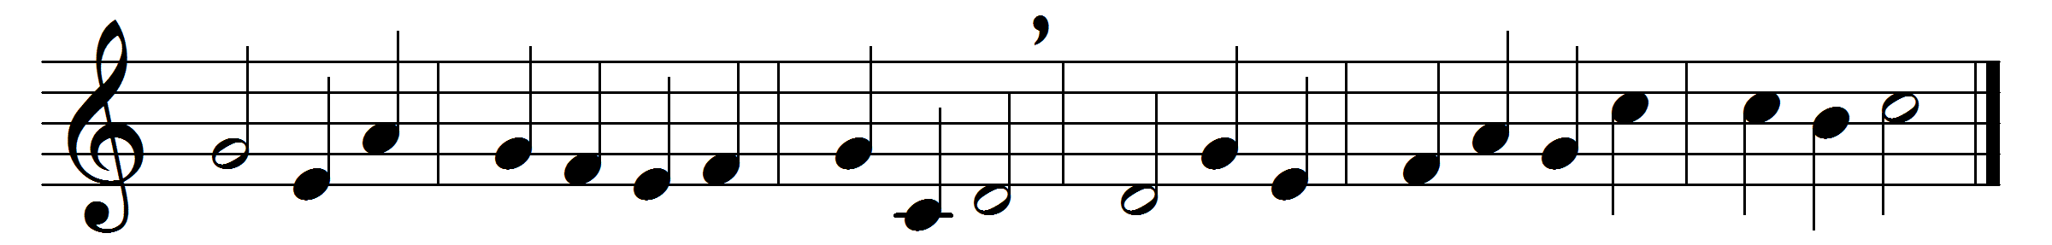

Her Virgin eyes saw God incarnate born,
when she to Bethlem came that happy morn:
how high her raptures then began to swell,
none but her own omniscient Son can tell.
As Eve, when she her fontal sin reviewed,
wept for herself and all she should include,
blest Mary, with man’s Saviour in embrace,
joyed for herself and for all human race.
All saints are by her Son’s dear influence blest;
she kept the very fountain at her breast:
the Son adored and nursed by the sweet Maid
a thousandfold of love for love repaid.
Heaven with transcendent joys her entrance graced,
near to his throne her Son his Mother placed;
and here below, now she’s of heaven possest,
all generations are to call her blest.

Words: Thomas Ken (1637-1711)
Music: Melody and bass by Henry Lawes (1596-1662)

