The God whom earth and sea and sky AMNS 309 Melody: Warrington L.M.
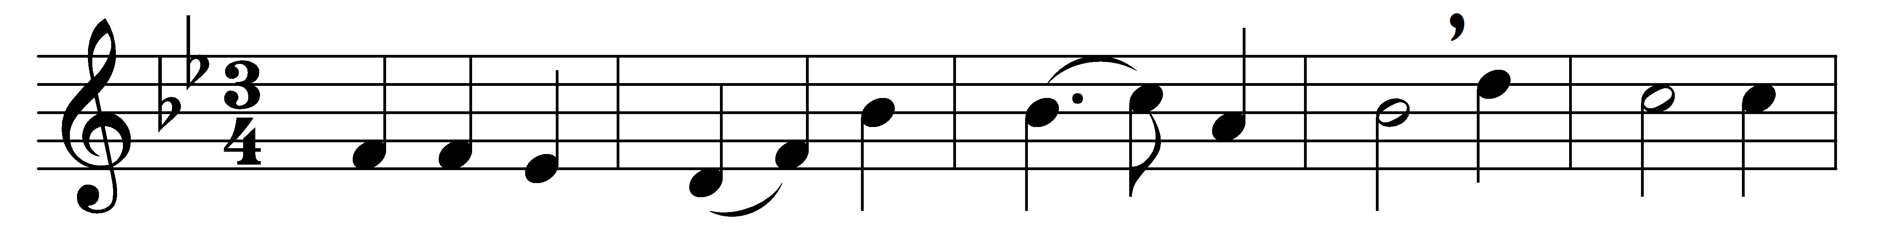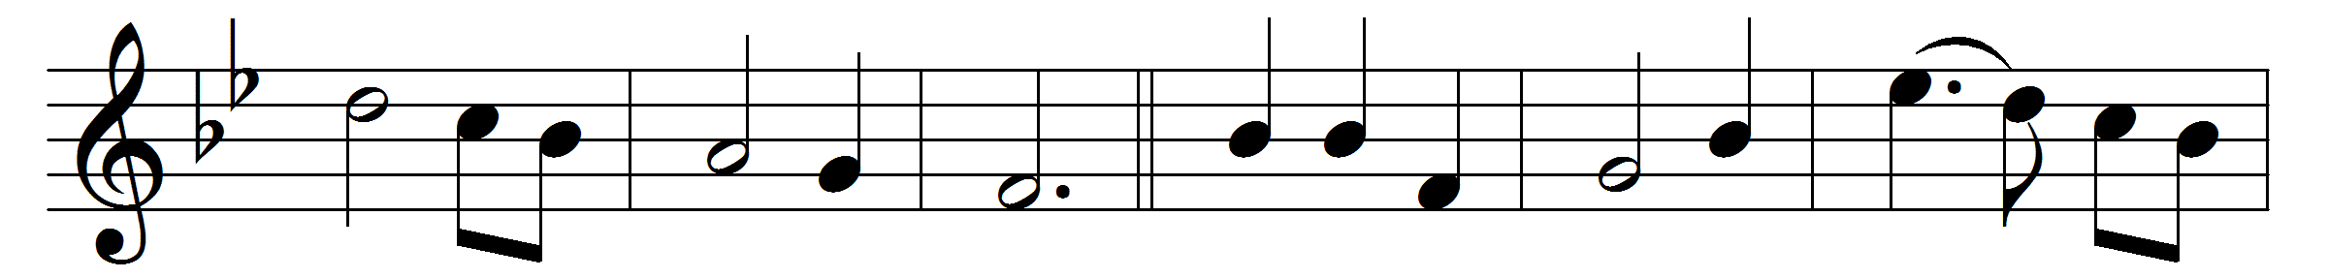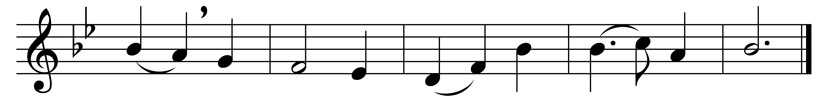

The God whom earth and sea and sky
adore and laud and magnify,
whose might they own, whose praise they tell,
in Mary’s body deigned to dwell.

O Mother blest, the chosen shrine
wherein the Architect divine,
whose hand contains the earth and sky,
vouchsafed in hidden guise to lie:

blest in the message Gabriel brought;
blest in the work the Spirit wrought;
most blest, to bring to human birth
the long Desired of all the earth.

O Lord, the Virgin-born, to thee
eternal praise and glory be,
whom with the Father we adore
and Holy Ghost for evermore.

Words: Venantius Fortunatus (c. 530-c. 600), translated by John Mason Neale (1818-1866)
Music: Ralph Harrison (1748-1810)

