Palms of glory, raiment bright AMNS 307 Melody: Palms of Glory 7 7. 7 7.
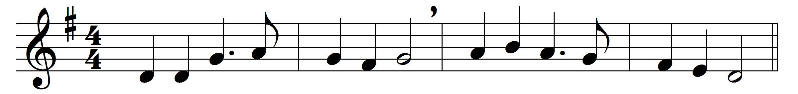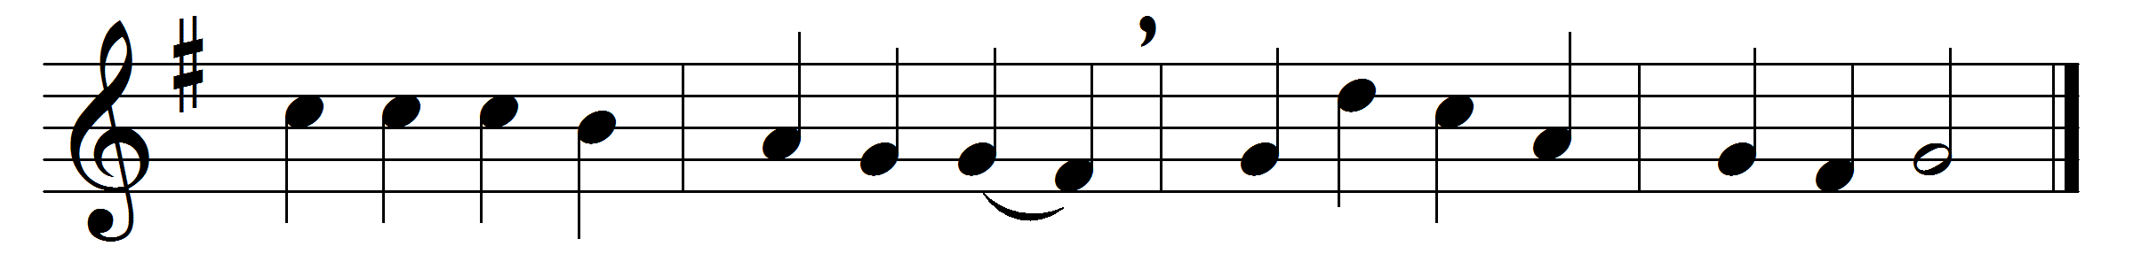

Palms of glory, raiment bright,
crowns that never fade away,
gird and deck the saints in light:
priests and kings and conquerors they.
Yet the conquerors bring their palms
to the Lamb amidst the throne,
and proclaim in joyful psalms
victory through his Cross alone.
Kings for harps their crowns resign,
crying, as they strike the chords,
‘Take the kingdom, it is thine,
King of kings and Lord of lords.’

Round the altar priests confess,
if their robes are white as snow,
’twas the Saviour’s righteousness,
and his blood, that made them so.
They were mortal too like us:
O, when we like them must die,
may our souls translated thus
triumph, reign, and shine on high.

Words: James Montgomery (1771-1854)
Music: William Dalrymple Maclagan (1826-1910)

