Lo, round the throne, a glorious band AMNS 303 Melody: Whitehall (Sandys’ Psalm 8) L.M.
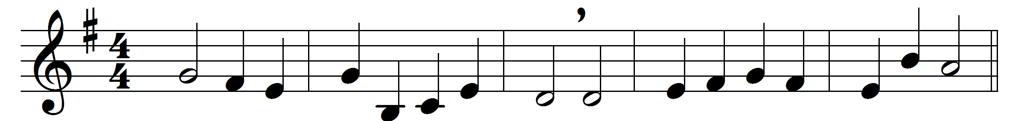

Lo, round the throne, a glorious band,
the saints in countless myriads stand,
of every tongue redeemed to God,
arrayed in garments washed in blood.

Through tribulation great they came;
they bore the cross, despised the shame;
from all their labours now they rest,
in God’s eternal glory blest.

They see their Saviour face to face,
and sing the triumphs of his grace;
him day and night they ceaseless praise,
to him the loud thanksgiving raise:

‘Worthy the Lamb, for sinners slain,
through endless years to live and reign;
thou hast redeemed us by thy blood,
and made us kings and priests to God.’

O may we tread the sacred road
that saints and holy martyrs trod;
wage to the end the glorious strife,
and win, like them, a crown of life.

Words: Rowland Hill (1744-1833) and others
Music: Melody and bass by Henry Lawes (1596-1662)

