Soldiers, who are Christ’s below AMNS 302 Melody: Orientis Partibus 7 7. 7 7.
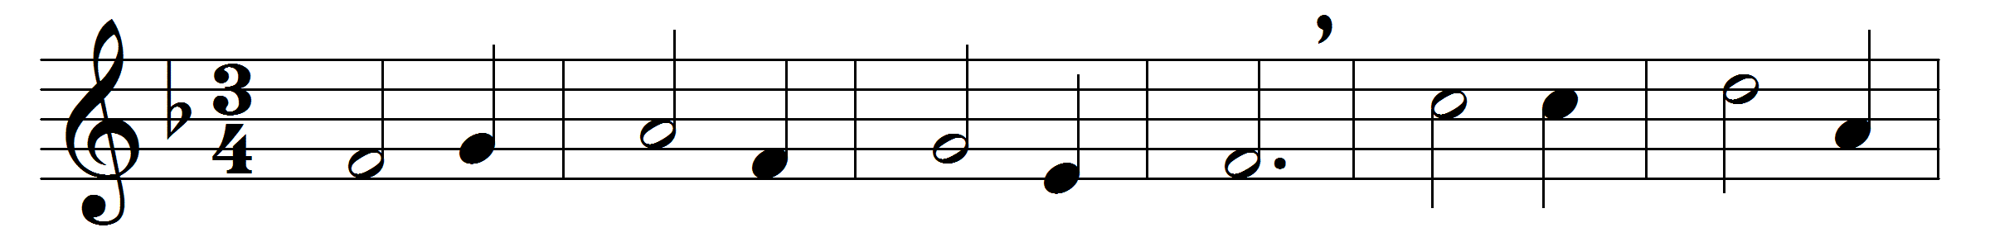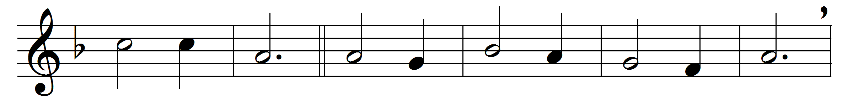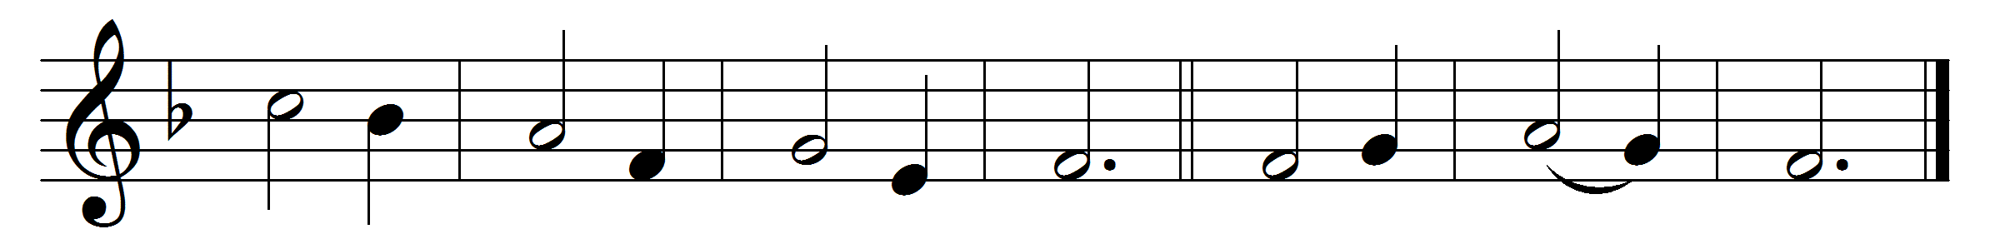

Soldiers, who are Christ’s below,
strong in faith resist the foe:
boundless is the pledged reward
unto them who serve the Lord.
Alleluia.

’Tis no palm of fading leaves
that the conqueror’s hand receives;
joys are his, serene and pure,
light that ever shall endure.
Alleluia.

For the souls that overcome
waits the beauteous heavenly home,
where the blessèd evermore
tread on high the starry floor.
Alleluia.

Passing soon and little worth
are the things that tempt on earth;
heavenward lift thy soul’s regard:
God himself is thy reward.
Alleluia.

Father, who the crown dost give,
Saviour, by whose death we live,
Spirit, who our hearts dost raise,
Three in One, thy name we praise.
Alleluia.

Words: Latin, 18th century, translated by John Haldenby Clark (1839-1888)
Music: Office of Pierre de Corbeil (d. 1222)

