Captains of the saintly band AMNS 299 Melody: University College 7 7. 7 7.
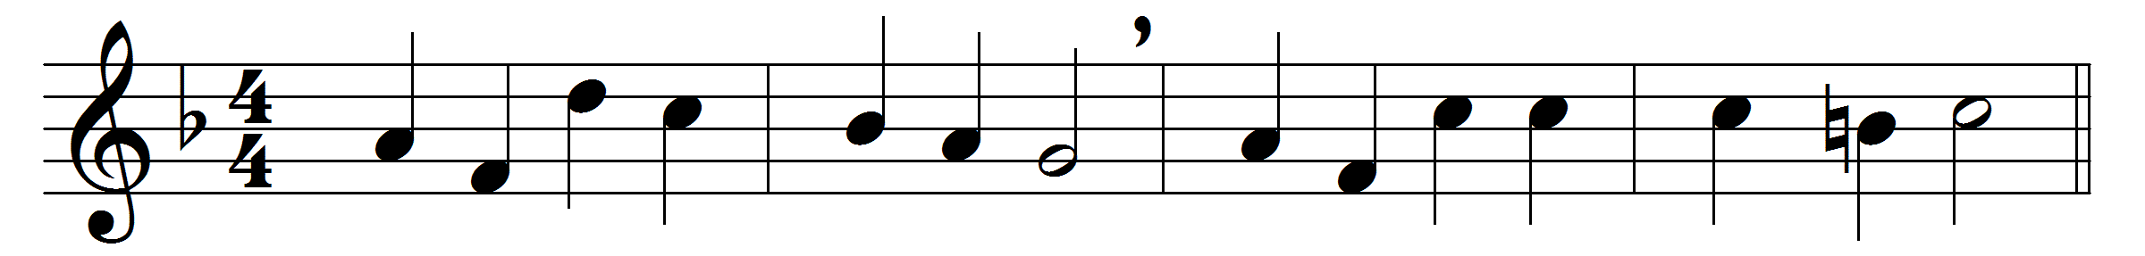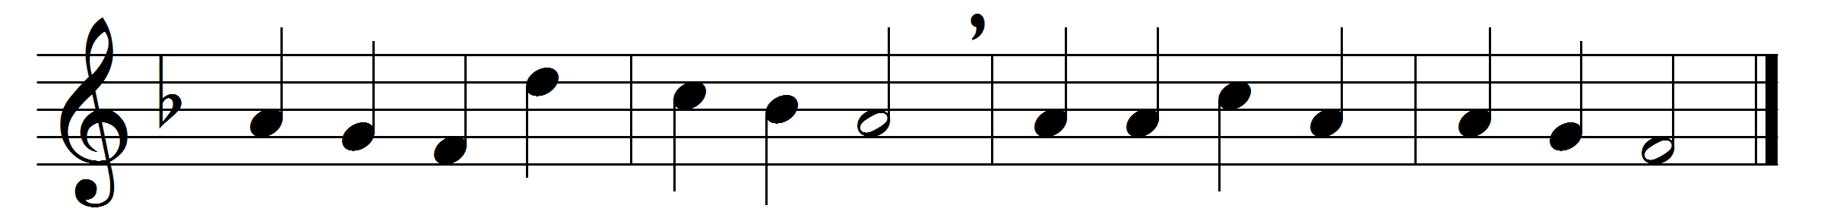

Captains of the saintly band,
lights who lighten every land,
princes who with Jesus dwell,
judges of his Israel;
on the nations sunk in night
ye have shed the Gospel light;
sin and error flee away,
truth reveals the promised day.
Not by warrior’s spear and sword,
not by art of human word,
preaching but the cross of shame,
rebel hearts for Christ ye tame.
Earth, that long in sin and pain
groaned in Satan’s deadly chain,
now to serve its God is free
in the law of liberty.
Distant lands with one acclaim
tell the honour of your name,
who, wherever man has trod,
teach the mysteries of God.
Glory to the Three in One
while eternal ages run,
who from deepest shades of night
called us to his glorious light.

Words: Jean-Baptiste de Santeuil (1630-1697), translated by Henry Williams Baker (1821-1877)
Music: Henry John Gauntlett (1805-1876)

