Rejoice, O land, in God thy might AMNS 296 Melody: Wareham L.M.
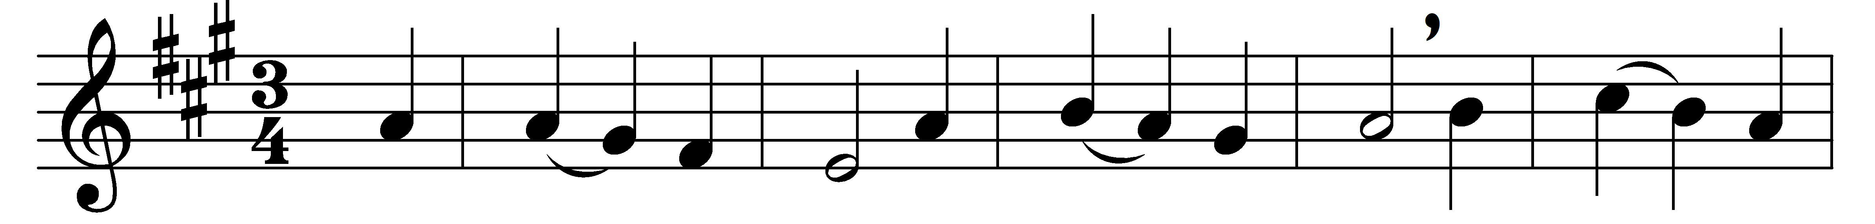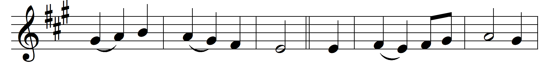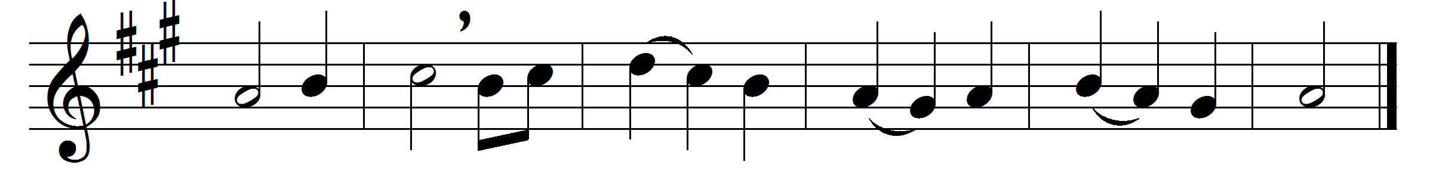

Rejoice, O land, in God thy might;
his will obey, him serve aright;
for thee the saints uplift their voice:
fear not, O land, in God rejoice.
Glad shalt thou be, with blessing crowned,
with joy and peace thou shalt abound;
yea, love with thee shall make his home
until thou see God’s kingdom come.
He shall forgive thy sins untold:
remember thou his love of old;
walk in his way, his word adore,
and keep his truth for evermore.

Words: Robert Bridges (1844-1930)
Music: Melody by William Knapp (1698-1768)

