God save our gracious King AMNS 293 Melody: National Anthem 6 6 4. 6 6 6 4.
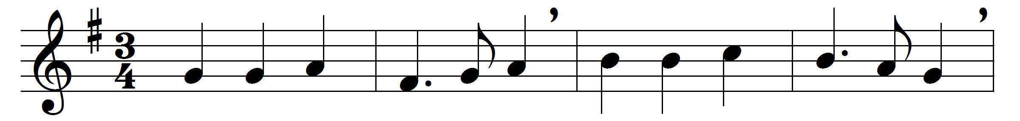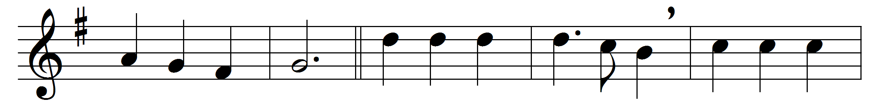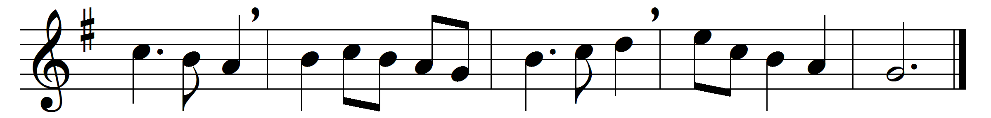

God save our gracious King,
long live our noble King,
God save the King.
Send him victorious,
happy and glorious,
long to reign over us:
God save the King.
O Lord our God, arise,
scatter our enemies,
and make them fall;
confound their politics,
frustrate their knavish tricks;
on thee our hopes we fix:
God save us all.
Thy choicest gifts in store
on him be pleased to pour,
long may he reign.
May he defend our laws,
and ever give us cause
to sing with heart and voice,
God save the King.
Words: Anonymous
Music: Thesaurus Musicus, c. 1743

