Eternal Father, strong to save AMNS 292 Melody: Melita 8 8. 8 8. 8 8.
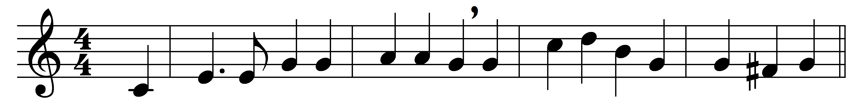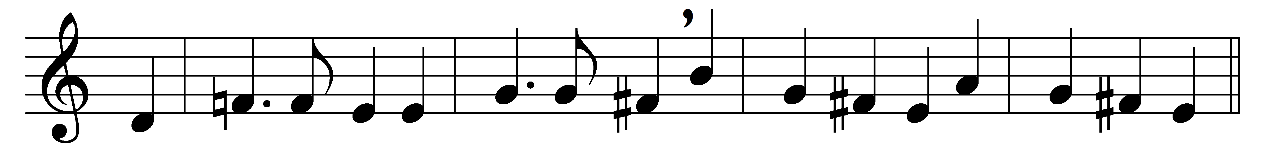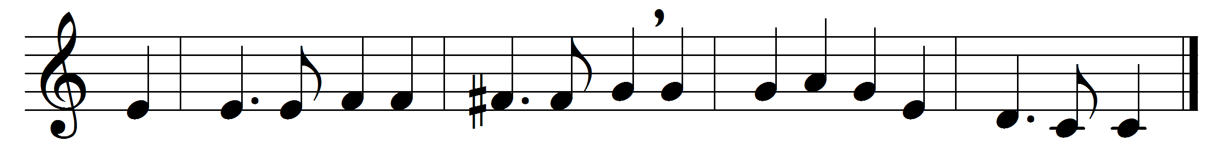

Eternal Father, strong to save,
whose arm hath bound the restless wave,
who bidd’st the mighty ocean deep
its own appointed limits keep:
O hear us when we cry to thee
for those in peril on the sea.
O Christ, whose voice the waters heard
and hushed their raging at thy word,
who walkedst on the foaming deep,
and calm amid the storm didst sleep:
O hear us when we cry to thee
for those in peril on the sea.
O Holy Spirit, who didst brood
upon the waters dark and rude,
and bid their angry tumult cease,
and give, for wild confusion, peace:
O hear us when we cry to thee
for those in peril on the sea.
O Trinity of love and power,
our brethren shield in danger’s hour;
from rock and tempest, fire and foe,
protect them wheresoe’er they go:
thus evermore shall rise to thee
glad hymns of praise from land and sea.

Words: William Whiting (1825-1878)
Music: John Bacchus Dykes (1823-1876)

