To thee, O Lord, our hearts we raise AMNS 291 Melody: Golden Sheaves 8 7. 8 7. D.
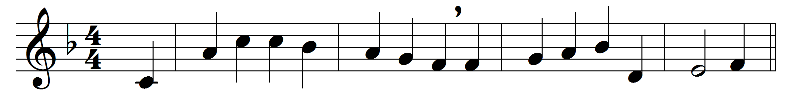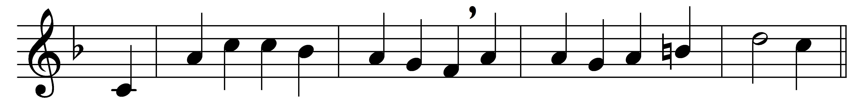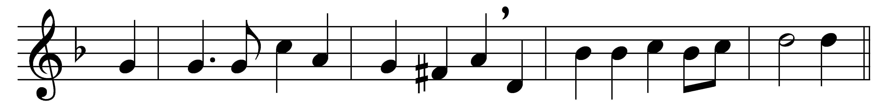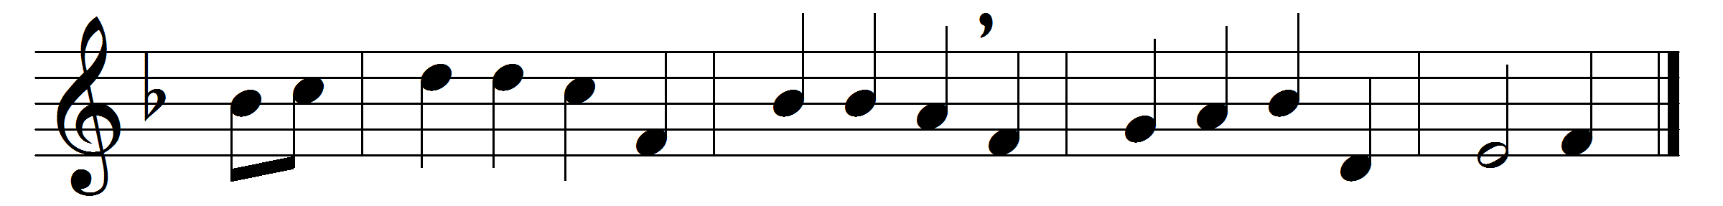

To thee, O Lord, our hearts we raise
in hymns of adoration,
to thee bring sacrifice of praise
with shouts of exultation:
bright robes of gold the fields adorn,
the hills with joy are ringing,
the valleys stand so thick with corn
that even they are singing.

And now, on this our festal day,
thy bounteous hand confessing,
upon thine altar, Lord, we lay
the first-fruits of thy blessing:
by thee the souls of men are fed
with gifts of grace supernal;
thou who dost give us earthly bread;
give us the bread eternal.

We bear the burden of the day,
and often toil seems dreary;
but labour ends with sunset ray,
and rest comes for the weary:
may we, the angel-reaping o’er,
stand at the last accepted,
Christ’s golden sheaves for evermore
to garners bright elected.

O blessèd is that land of God,
where saints abide for ever;
where golden fields spread far and broad,
where flows the crystal river:
the strains of all its holy throng
with ours to-day are blending;
thrice blessèd is that harvest-song
which never hath an ending.

Words: William Chatterton Dix (1837-1898)
Music: Arthur Sullivan (1842-1900)

