We plough the fields, and scatter AMNS 290 Melody: Wir pflügen 7 6. 7 6. D. 6 6. 8 4.
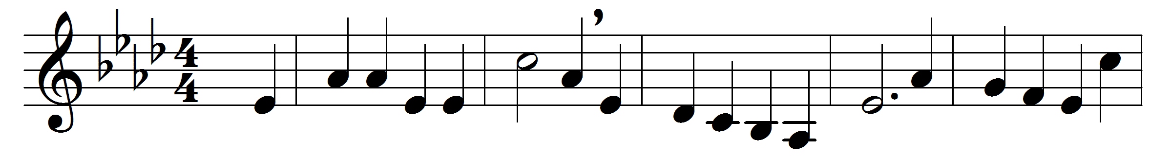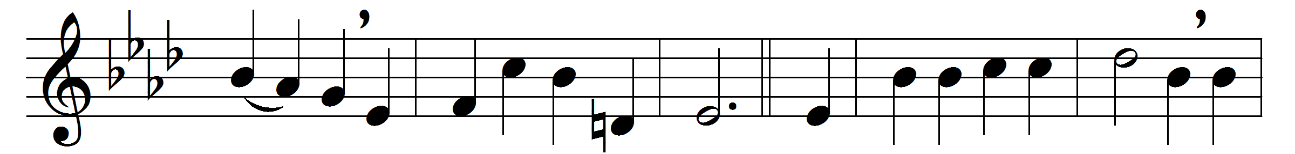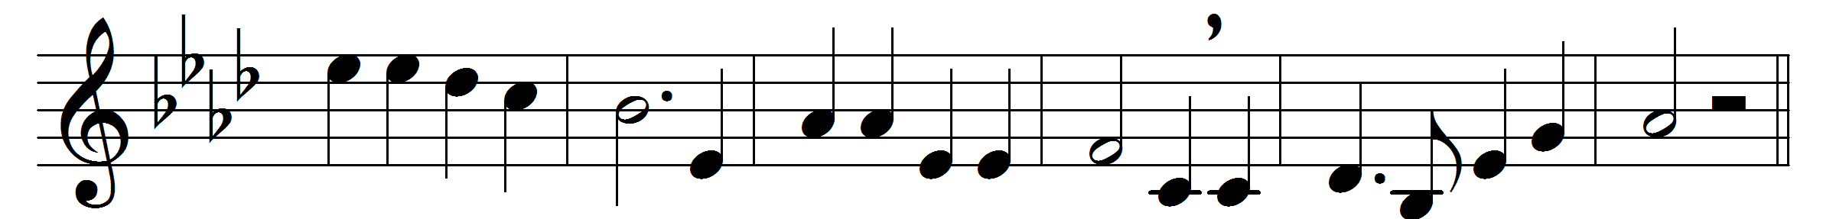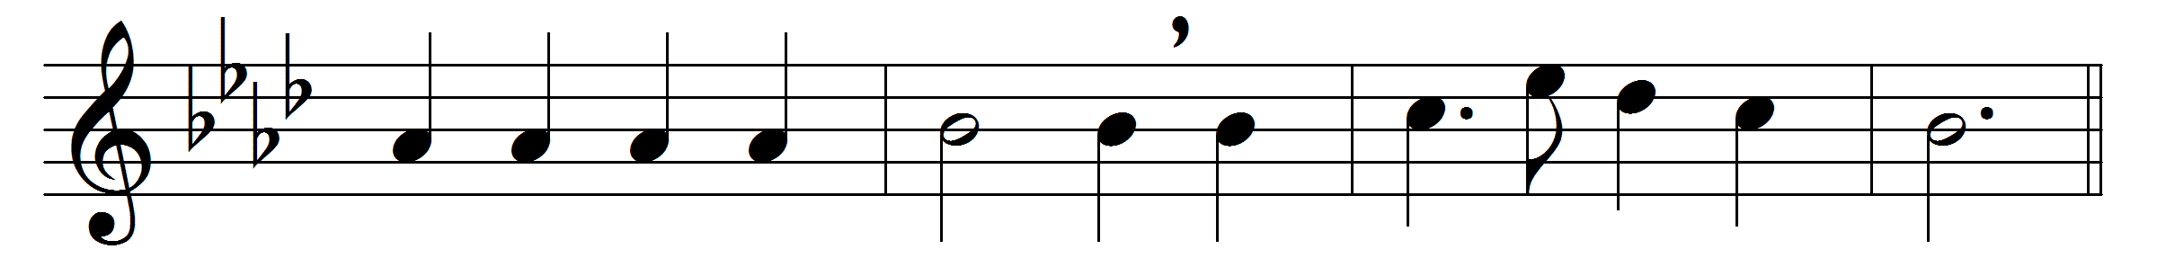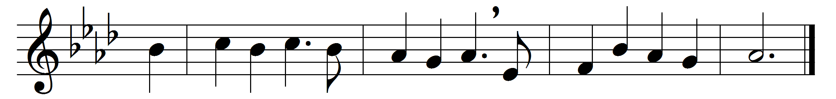

We plough the fields, and scatter
the good seed on the land,
but it is fed and watered
by God’s almighty hand:
he sends the snow in winter,
the warmth to swell the grain,
the breezes, and the sunshine,
and soft, refreshing rain.
Refrain: All good gifts around us
are sent from heaven above;
then thank the Lord, O thank the Lord,
for all his love.
He only is the maker
of all things near and far;
he paints the wayside flower,
he lights the evening star;
the winds and waves obey him,
by him the birds are fed;
much more to us, his children,
he gives our daily bread.
Refrain
We thank thee then, O Father,
for all things bright and good,
the seed-time and the harvest,
our life, our health, our food.
Accept the gifts we offer
for all thy love imparts,
and, what thou most desirest,
our humble, thankful hearts.
Refrain

Words: Matthias Claudius (1740-1815), translated by Jane Montgomery Campbell (1817-1878)
Music: Melody by Johann Abraham Peter Schulz (1747-1800)

