Come, ye thankful people, come AMNS 289 Melody: St. George 7 7. 7 7. D.
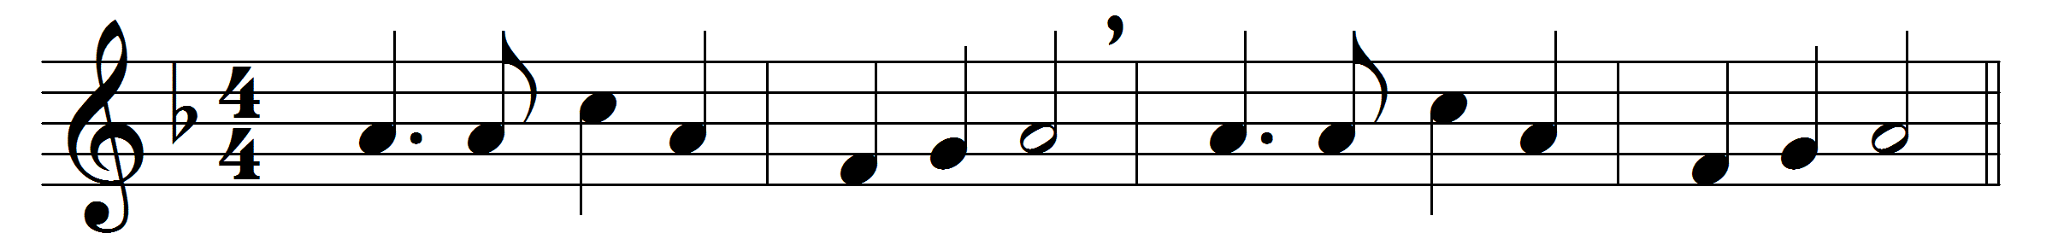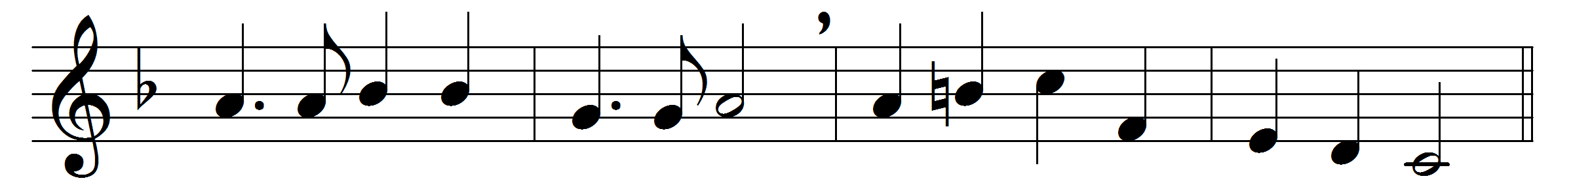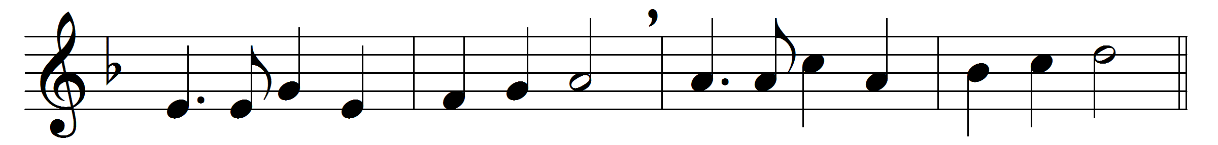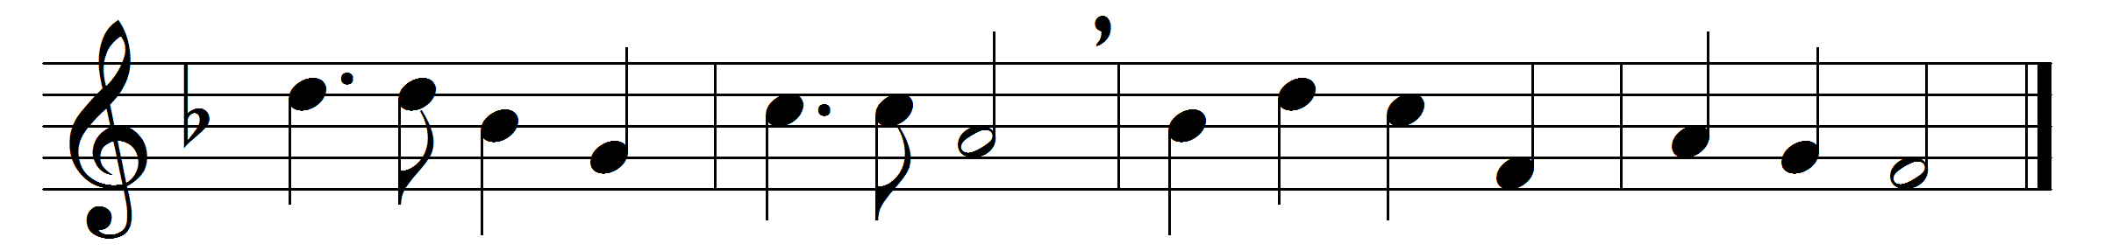

Come, ye thankful people, come,
raise the song of harvest-home:
all is safely gathered in,
ere the winter storms begin;
God, our maker, doth provide
for our wants to be supplied:
come to God’s own temple, come;
raise the song of harvest-home.
All this world is God’s own field,
fruit unto his praise to yield;
wheat and tares therein are sown,
unto joy or sorrow grown;
ripening with a wondrous power
till the final harvest-hour:
grant, O Lord of life, that we
holy grain and pure may be.
For we know that thou wilt come,
and wilt take thy people home;
from thy field wilt purge away
all that doth offend, that day;
and thine angels charge at last
in the fire the tares to cast,
but the fruitful ears to store
in thy garner evermore.
Come then, Lord of mercy, come,
bid us sing thy harvest-home:
let thy saints be gathered in,
free from sorrow, free from sin:
all upon the golden floor
praising thee for evermore:
come, with all thine angels come,
bid us sing thy harvest-home.

Words: Henry Alford (1810-1871)
Music: George Job Elvey (1816-1893)

