O Lord of heaven and earth and sea AMNS 287 Melody: Es ist kein Tag 8 8 8. 4.
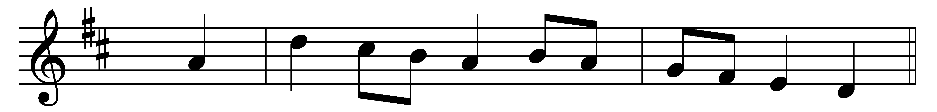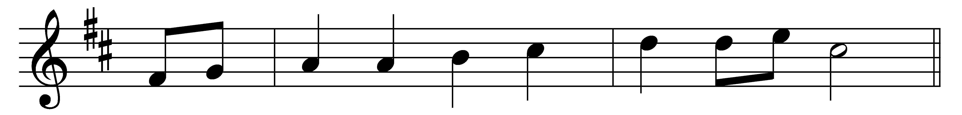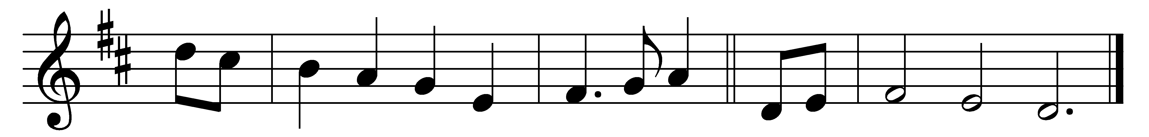

O Lord of heaven and earth and sea,
to thee all praise and glory be.
How shall we show our love to thee,
who givest all?
The golden sunshine, vernal air,
sweet flowers and fruit, thy love declare;
when harvests ripen, thou art there,
who givest all.
For peaceful homes, and healthful days,
for all the blessings earth displays,
we owe thee thankfulness and praise,
who givest all.
Thou didst not spare thine only Son,
but gav’st him for a world undone,
and freely with that blessèd One
thou givest all.
Thou giv’st the Holy Spirit’s dower,
Spirit of life and love and power,
and dost his sevenfold graces shower
upon us all.
For souls redeemed, for sins forgiven,
for means of grace and hopes of heaven,
Father, what can to thee be given,
who givest all?
We lose what on ourselves we spend,
we have as treasure without end
whatever, Lord, to thee we lend,
who givest all:
To thee, from whom we all derive
our life, our gifts, our power to give:
O may we ever with thee live,
who givest all.

Words: Christopher Wordsworth (1807-1885)
Music: Melody by Johann David Meyer (1636-1696)

