Thine arm, O Lord, in days of old AMNS 285 Melody: St. Matthew D.C.M.
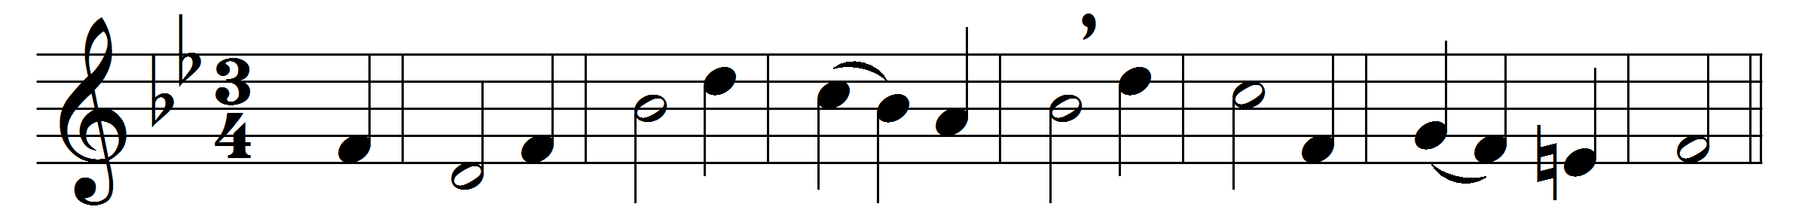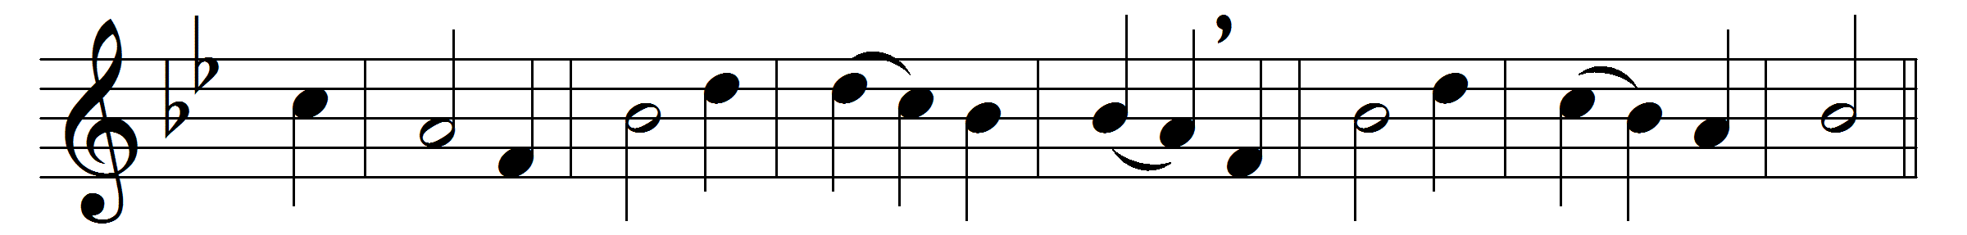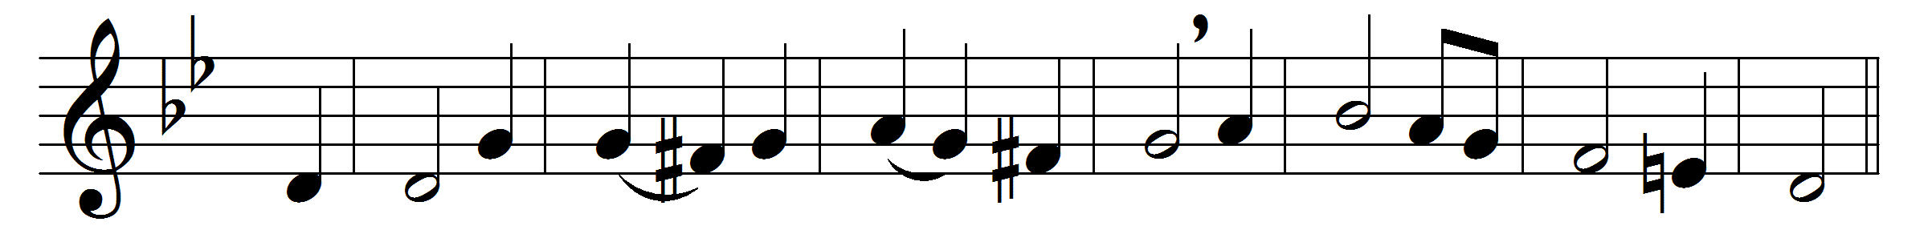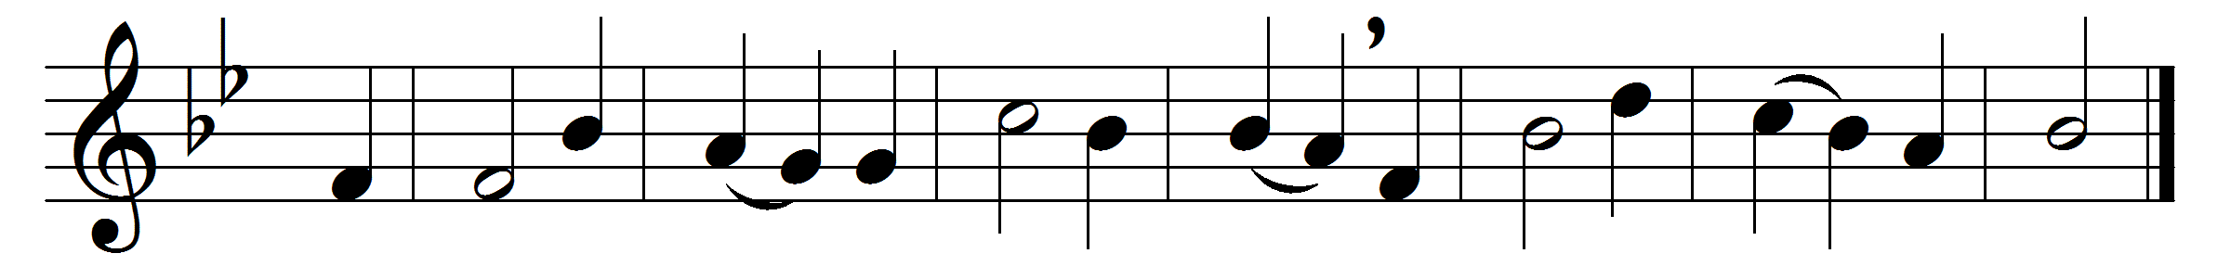

Thine arm, O Lord, in days of old
was strong to heal and save;
it triumphed o’er disease and death,
o’er darkness and the grave:
to thee they went, the blind, the dumb,
the palsied and the lame,
the leper with his tainted life,
the sick with fevered frame.
And lo, thy touch brought life and health,
gave speech and strength and sight;
and youth renewed and frenzy calmed
owned thee, the Lord of light:
and now, O Lord, be near to bless,
almighty as of yore,
in crowded street, by restless couch,
as by Gennesareth’s shore.
Be thou our great deliverer still,
thou Lord of life and death;
restore and quicken, soothe and bless,
with thine almighty breath:
to hands that work, and eyes that see,
give wisdom’s heavenly lore,
that whole and sick, and weak and strong,
may praise thee evermore.

Words: Edward Hayes Plumptre (1821-1891)
Music: William Croft (1678-1727)

