In our day of thanksgiving AMNS 284 Melody: Was Lebet Irregular metre
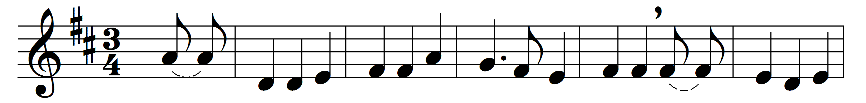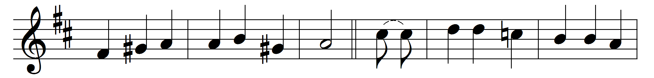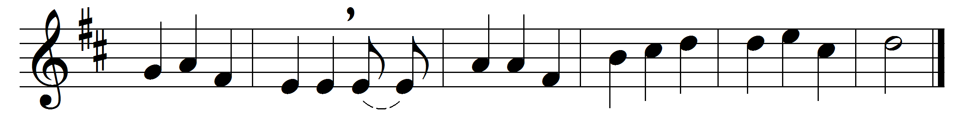

In our day of thanksgiving one psalm let us offer
for the saints who before us have found their reward;
when the shadow of death fell upon them, we sorrowed,
but now we rejoice that they rest in the Lord.
In the morning of life, and at noon, and at even,
he called them away from our worship below;
but not till his love, at the font and the altar,
had girt them with grace for the way they should go.
These stones that have echoed their praises are holy,
and dear is the ground where their feet have once trod;
yet here they confessed they were strangers and pilgrims,
and still they were seeking the city of God.
Sing praise, then, for all who here sought and here found him,
whose journey is ended, whose perils are past:
they believed in the light; and its glory is round them,
where the clouds of earth’s sorrow are lifted at last.

Words: William Henry Draper (1855-1933)
Music: Melody from Rheinhardt MS (Üttingen, 1754)

