Lord, pour thy Spirit from on high AMNS 282 Melody: Melcombe L.M.
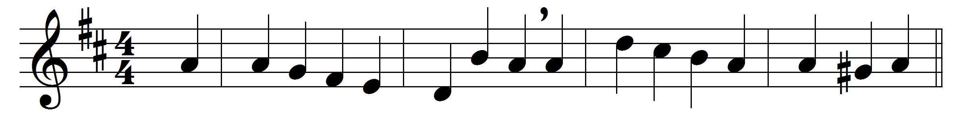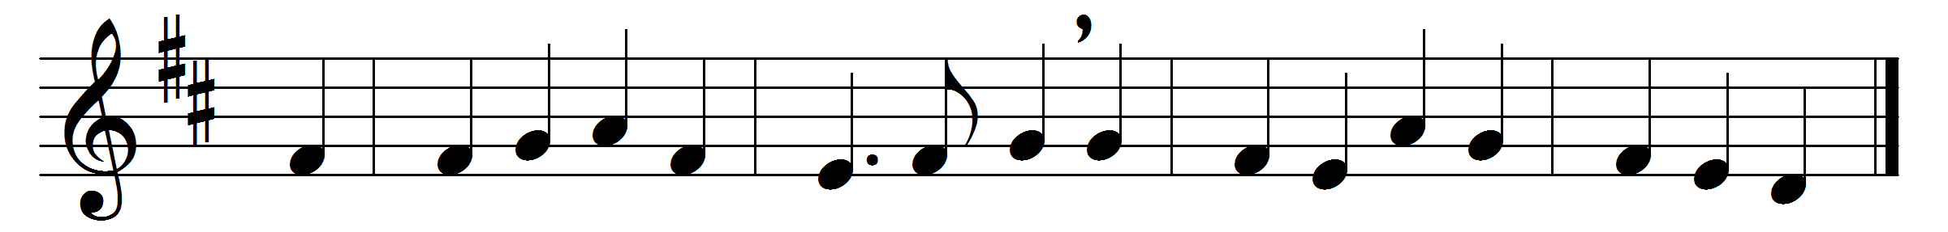

Lord, pour thy Spirit from on high,
and thine assembled servants bless;
graces and gifts to each supply,
and clothe thy priests with righteousness.
Within thy temple when they stand,
to teach the truth as taught by thee,
Saviour, like stars in thy right hand
let all thy Church’s pastors be.
Wisdom and zeal and faith impart,
firmness with meekness, from above,
to bear thy people in their heart,
and love the souls whom thou dost love;
to watch and pray and never faint,
by day and night their guard to keep,
to warn the sinner, cheer the saint,
to feed thy lambs and tend thy sheep.
So, when their work is finished here,
may they in hope their charge resign;
when the Chief Shepherd shall appear,
O God, may they and we be thine.

Words: James Montgomery (1771-1854)
Music: Samuel Webbe the elder (1740-1816)

