Jesu, Son of Mary AMNS 281 Melody: Caswall 6 5. 6 5.
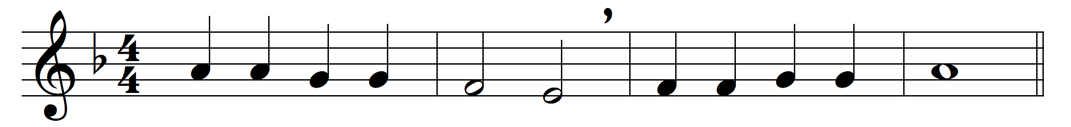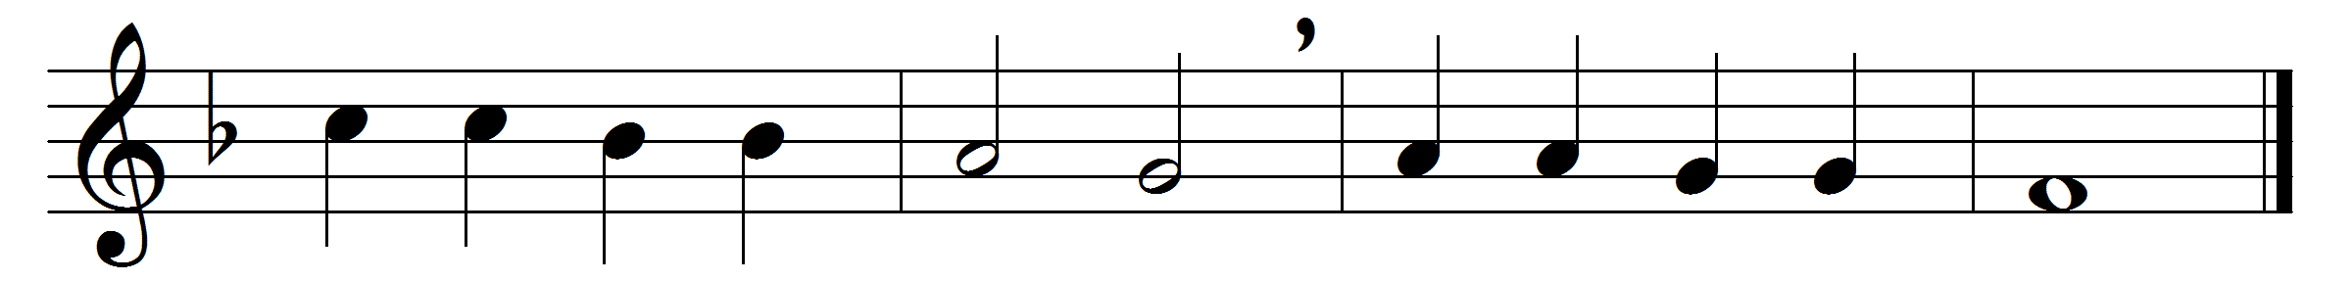

Jesu, Son of Mary,
fount of life alone,
here we hail thee present
on thine altar-throne:
humbly we adore thee,
Lord of endless might,
in the mystic symbols
veiled from earthly sight.
Think, O Lord, in mercy
on the souls of those
who, in faith gone from us,
now in death repose.
Here ’mid stress and conflict
toils can never cease;
there, the warfare ended,
bid them rest in peace.
Often were they wounded
in the deadly strife;
heal them, good Physician,
with the balm of life.
Every taint of evil,
frailty and decay,
good and gracious Saviour,
cleanse and purge away.
Rest eternal grant them,
after weary fight;
shed on them the radiance
of thy heavenly light.

Lead them onward, upward,
to the holy place,
where thy saints made perfect
gaze upon thy face.

Words: Translated from Swahili by Edmund Stuart Palmer (1856-1931)
Music: Friedrich Filitz (1804-1876)

