Glory in highest heaven AMNS 277 Melody: Hosanna in Excelsis 7 7. 4 4. 7. D.
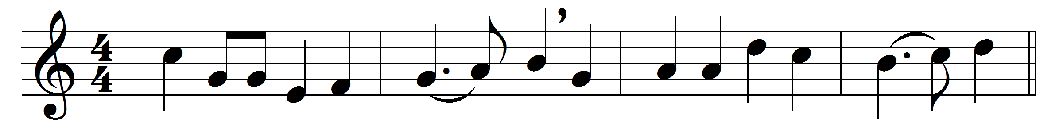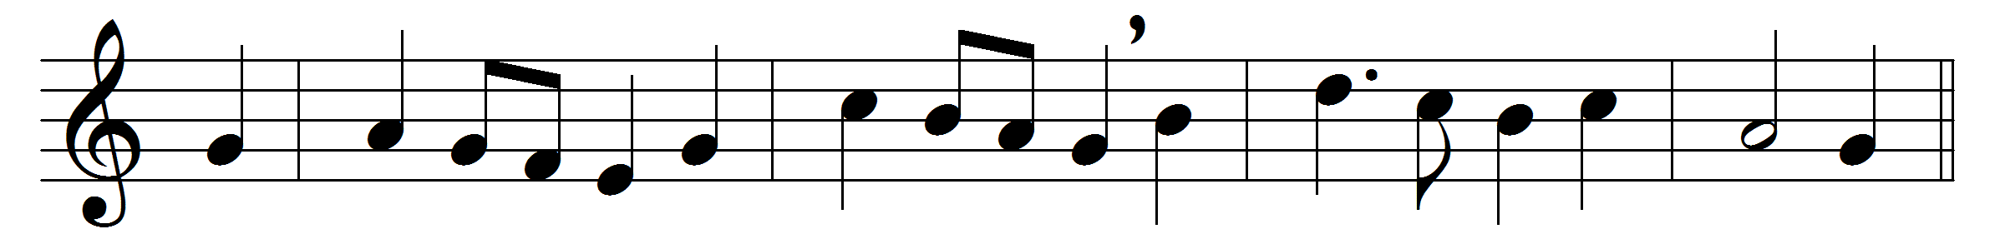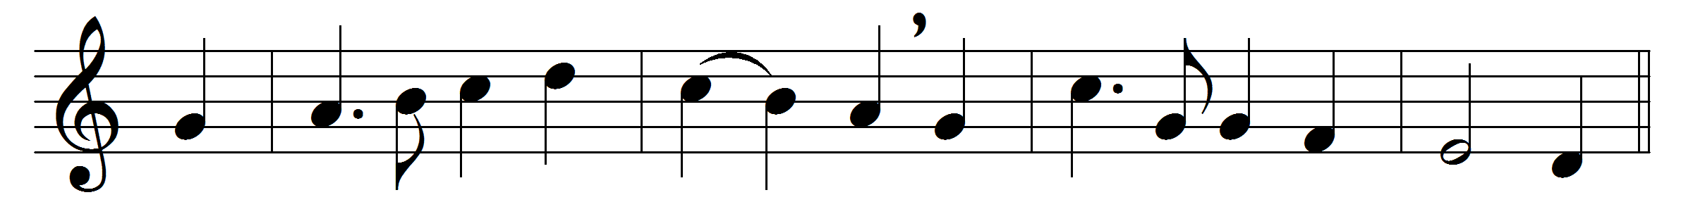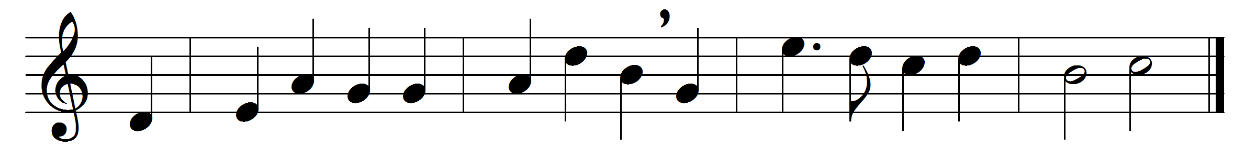

Glory in highest heaven
to our exalted Saviour,
who left behind
for all mankind
these tokens of his favour:
his bleeding love and mercy,
his all-redeeming passion;
who here displays,
and gives the grace
which brings us our salvation.
Louder than gathered waters,
or bursting peals of thunder,
we lift our voice
and speak our joys,
and shout our loving wonder.
Shout, all our elder brethren,
while we record the story
of him that came
and suffered shame,
to carry us to glory.
Angels in fixed amazement
around our altars hover,
with eager gaze
adore the grace
of our eternal Lover:
himself and all his fulness
who gives to the believer;
and by this bread
whoe’er are fed
shall live with God for ever.

Words: Charles Wesley (1707-1788)
Music: Sydney Hugo Nicholson (1875-1947)

