Here, O my Lord, I see thee face to face AMNS 274 Melody: Farley Castle 10 10. 10 10.
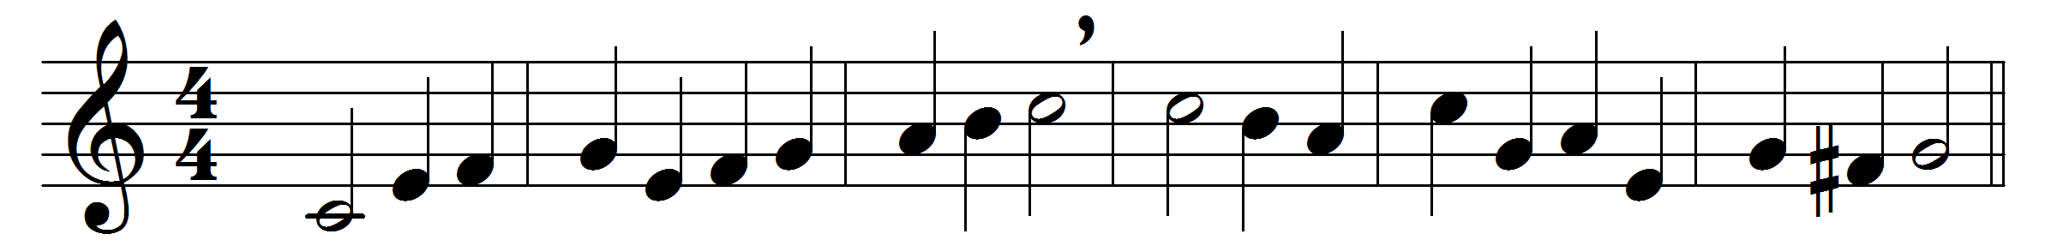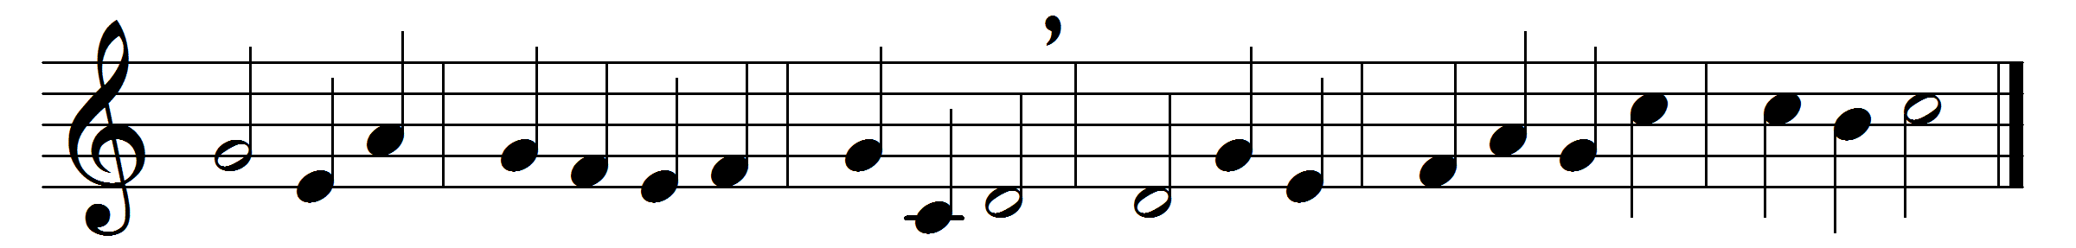

Here, O my Lord, I see thee face to face;
here faith would touch and handle things unseen;
here grasp with firmer hand the eternal grace,
and all my weariness upon thee lean.
Here would I feed upon the bread of God;
here drink with thee the royal wine of heaven;
here would I lay aside each earthly load;
here taste afresh the calm of sin forgiven.
I have no help but thine; nor do I need
another arm save thine to lean upon:
it is enough, my Lord, enough indeed,
my strength is in thy might, thy might alone.
Words: Horatius Bonar (1808-1889)
Music: Melody and bass by Henry Lawes (1596-1662)

