Bread of heaven, on thee we feed AMNS 271 Melody: Bread of Heaven 7 7. 7 7. 7 7
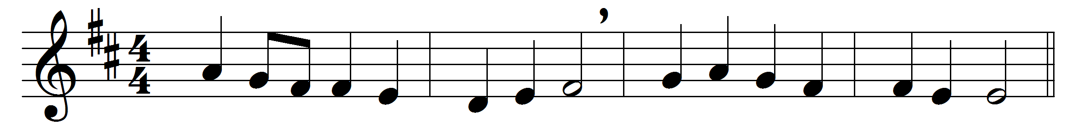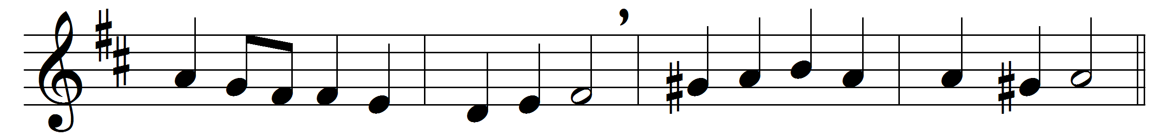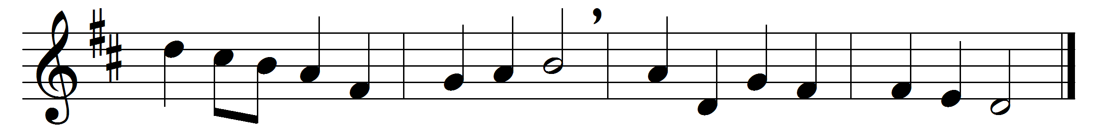

Bread of heaven, on thee we feed,
for thy flesh is meat indeed;
ever may our souls be fed
with this true and living bread;
day by day with strength supplied
through the life of him who died.
Vine of heaven, thy blood supplies
this blest cup of sacrifice;
Lord, thy wounds our healing give,
to thy Cross we look and live:
Jesus, may we ever be
grafted, rooted, built in thee.

Words: Josiah Conder (1789-1855)
Music: William Dalrymple Maclagan (1826-1910)

