Bread of the world in mercy broken AMNS 270 Melody: Les Commandemens 9 8. 9 8.
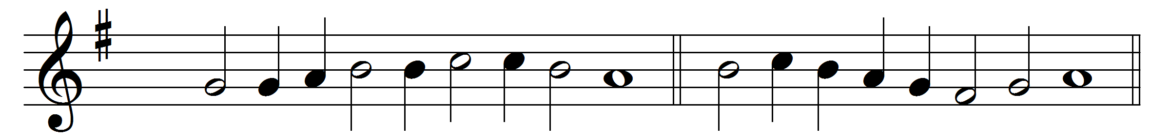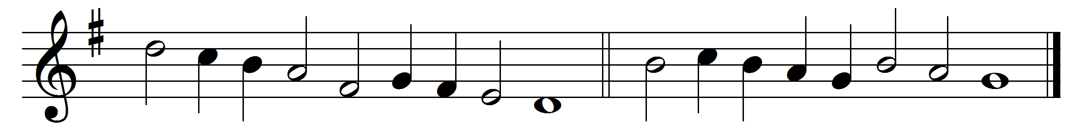

Bread of the world in mercy broken,
wine of the soul in mercy shed,
by whom the words of life were spoken,
and in whose death our sins are dead;
look on the heart by sorrow broken,
look on the tears by sinners shed;
and be thy feast to us the token
that by thy grace our souls are fed.

Words: Reginald Heber (1783-1826)
Music: Melody from La Forme des Prières, Strasbourg, 1545

