O come, O come, Emmanuel AMNS 26 Melody: Veni Emmanuel 8 8. 8 8. 8 8.
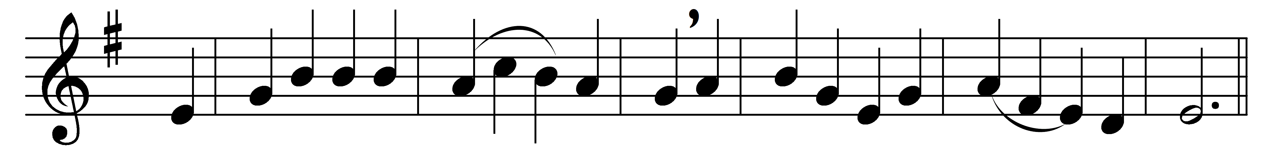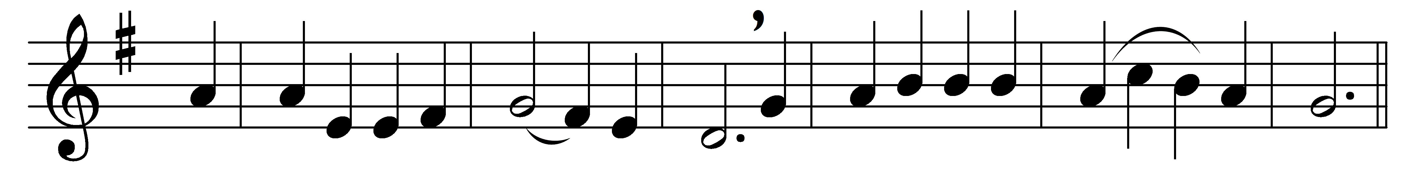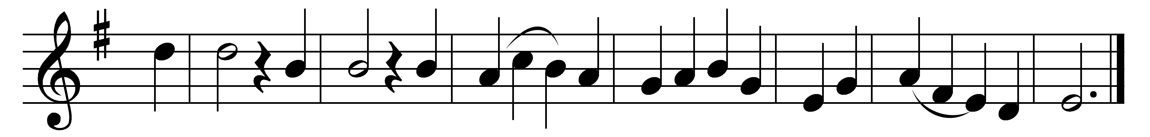

O come, O come, Emmanuel,
and ransom captive Israel,
that mourns in lonely exile here,
until the Son of God appear:
Refrain: Rejoice! Rejoice! Emmanuel
shall come to thee, O Israel.

O come, thou Rod of Jesse, free
thine own from Satan’s tyranny;
from depths of hell thy people save,
and give them victory o’er the grave:
Refrain

O come, thou Dayspring, come and cheer
our spirits by thine advent here;
disperse the gloomy clouds of night,
and death’s dark shadows put to flight:
Refrain

O come, thou Key of David, come,
and open wide our heavenly home;
make safe the way that leads on high,
and close the path to misery:
Refrain

O come, O come, thou Lord of Might,
who to thy tribes, on Sinai’s height,
in ancient times didst give the law
in cloud and majesty and awe:
Refrain

Words: Latin Advent Antiphons, translated by John Mason Neale (1818-1866)
Music: Melody from Hymnal Noted, 1856 (from a French Missal)

