We hail thy presence glorious AMNS 266 Melody: Crüger 7 6. 7 6. D.
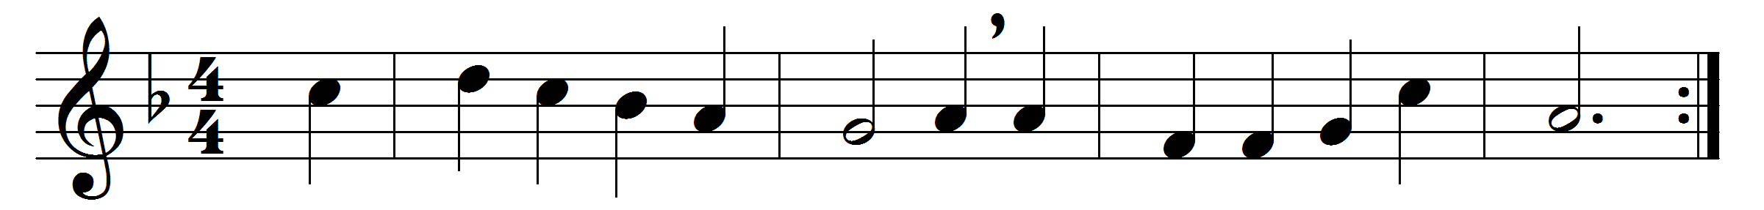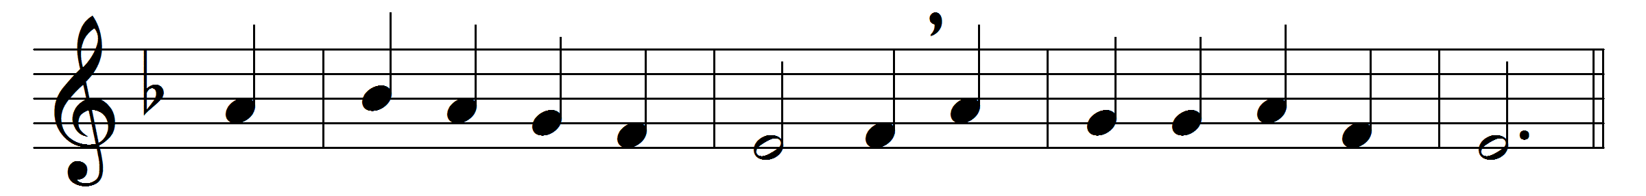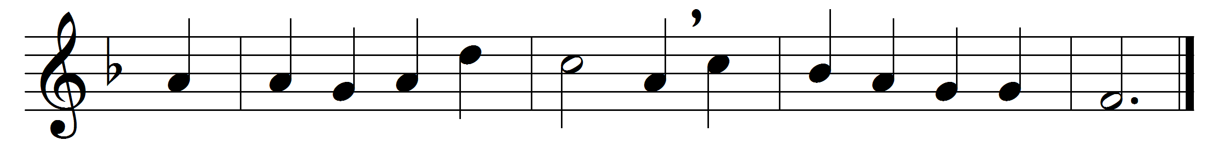

We hail thy presence glorious,
O Christ our great High Priest,
o’er sin and death victorious,
at thy thanksgiving feast:
as thou art interceding
for us in heaven above,
thy Church on earth is pleading
thy perfect work of love.
Through thee in every nation
thine own their hearts upraise,
off’ring one pure oblation,
one sacrifice of praise:
with thee in blest communion
the living and the dead
are joined in closest union,
one Body with one Head.
O living bread from heaven,
Jesu, our Saviour good,
who thine own self hast given
to be our souls’ true food;
for us thy body broken
hung on the Cross of shame:
this bread its hallowed token
we break in thy dear name.
O stream of love unending,
poured from the one true vine,
with our weak nature blending
the strength of life divine;
our thankful faith confessing
in thy life-blood outpoured,
we drink this cup of blessing
and praise thy name, O Lord.
May we thy word believing
thee through thy gifts receive,
that, thou within us living,
we all to God may live;
draw us from earth to heaven
till sin and sorrow cease,
forgiving and forgiven,
in love and joy and peace.

Words: Richard Godfrey Parsons (1882-1948)
Music: Adapted from Johann Crüger (1598-1662) by William Henry Monk (1823-1889)

