Alleluia, sing to Jesus! AMNS 262 Melody: Hyfrydol 8 7. 8 7. D.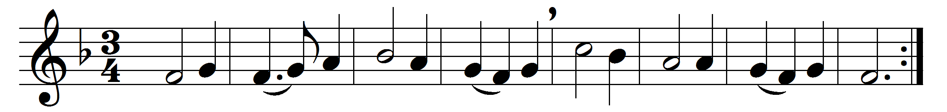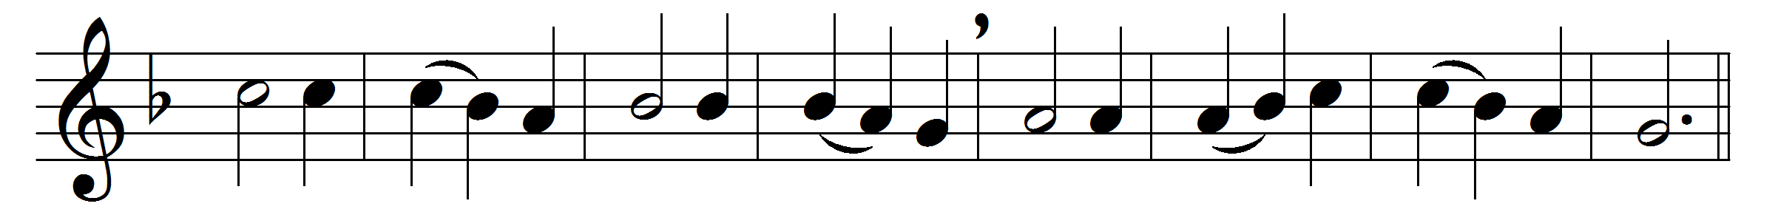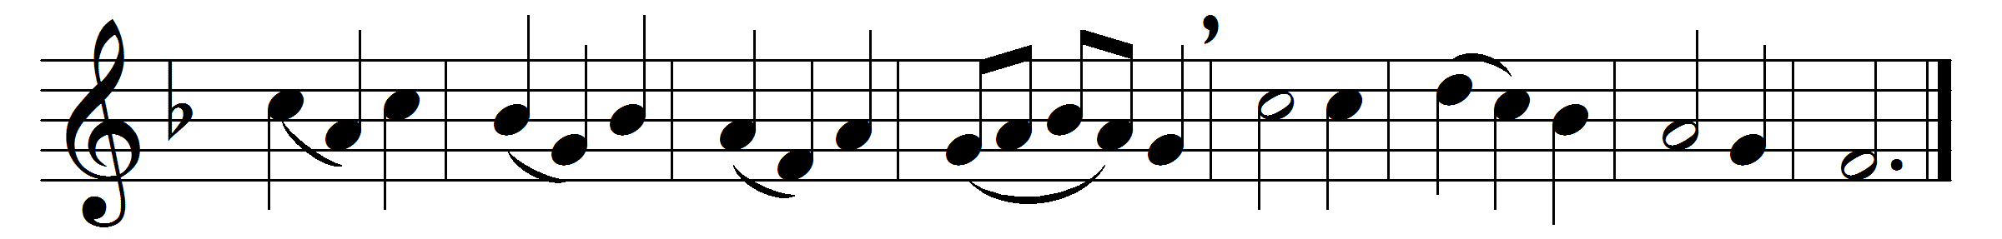

Alleluia, sing to Jesus!
his the sceptre, his the throne;
Alleluia, his the triumph,
his the victory alone:
hark, the songs of peaceful Sion
thunder like a mighty flood;
Jesus out of every nation
hath redeemed us by his blood.
Alleluia, not as orphans
are we left in sorrow now;
Alleluia, he is near us,
faith believes, nor questions how:
though the cloud from sight received him,
when the forty days were o’er,
shall our hearts forget his promise,
‘I am with you evermore’?
Alleluia, bread of angels,
thou on earth our food, our stay;
Alleluia, here the sinful
flee to thee from day to day:
Intercessor, Friend of sinners,
earth’s Redeemer, plead for me,
where the songs of all the sinless
sweep across the crystal sea.
Alleluia, King eternal,
thee the Lord of lords we own;
Alleluia, born of Mary,
earth thy footstool, heaven thy throne:
thou within the veil hast entered,
robed in flesh, our great High Priest;
thou on earth both Priest and Victim
in the eucharistic feast.

Words: William Chatterton Dix (1837-1898)
Music: Melody by Rowland Hugh Prichard (1811-1887)

