Once, only once, and once for all AMNS 261 Melody: Albano C.M.
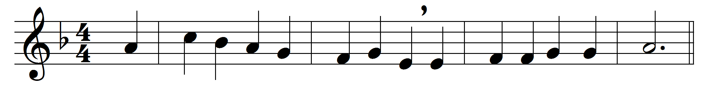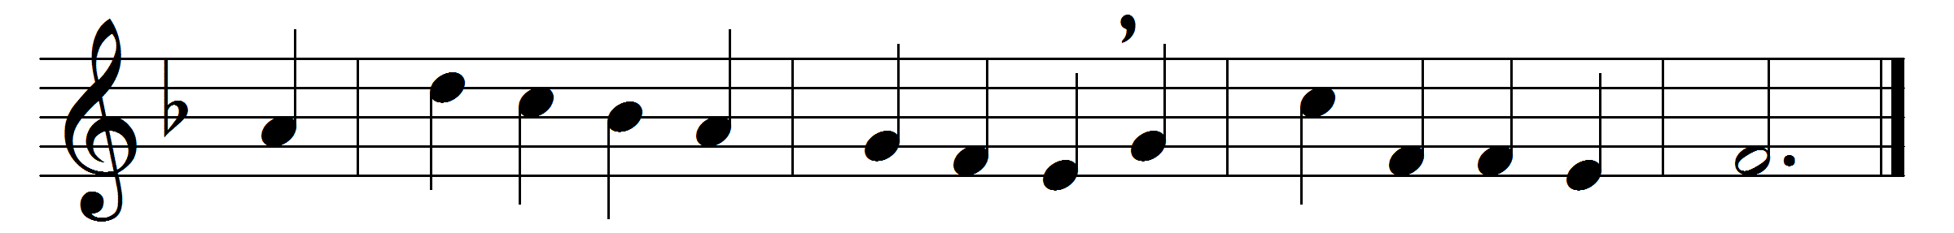

Once, only once, and once for all,
his precious life he gave;
before the Cross our spirits fall,
and own it strong to save.
‘One offering, single and complete,’
with lips and hearts we say;
but what he never can repeat
he shows forth day by day.
For, as the priest of Aaron’s line
within the holiest stood,
and sprinkled all the mercy-shrine
with sacrificial blood;
so he who once atonement wrought,
our Priest of endless power,
presents himself for those he bought
in that dark noontide hour.
His manhood pleads where now it lives
on heaven’s eternal throne,
and where in mystic rite he gives
its presence to his own.

And so we show thy death, O Lord,
till thou again appear;
and feel, when we approach thy board,
we have an altar here.
All glory to the Father be,
all glory to the Son,
all glory, Holy Ghost, to thee,
while endless ages run.

Words: William Bright (1824-1901)
Music: Vincent Novello (1781-1861)

