The advent of our King AMNS 25 Melody: Franconia S.M.

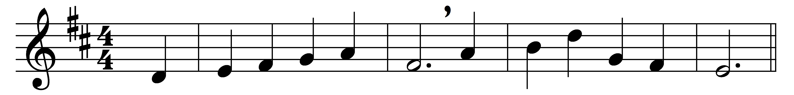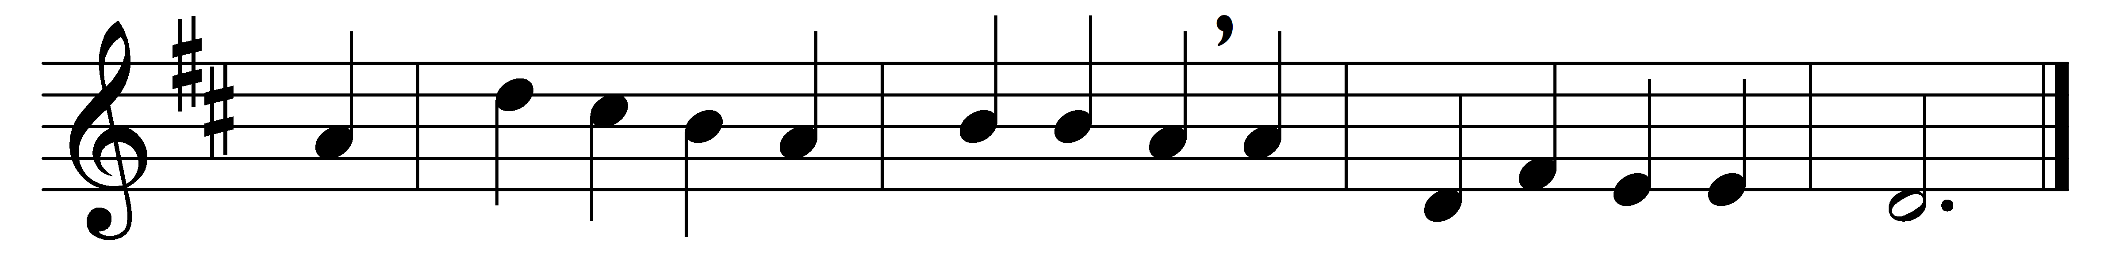

The advent of our King
our prayers must now employ,
and we must hymns of welcome sing
in strains of holy joy.

The everlasting Son
incarnate deigns to be;
himself a servant’s form puts on,
to set his servants free.

Daughter of Sion, rise
to meet thy lowly King;
nor let thy faithless heart despise
the peace he comes to bring.

As Judge, on clouds of light,
he soon will come again,
and his true members all unite
with him in heaven to reign.

All glory to the Son
who comes to set us free,
with Father, Spirit, ever One,
through all eternity.

Words: Charles Coffin (1676-1749), translated by John Chandler (1806-1876)
Music: Harmonischer Liederschatz (1738), adapted by William Henry Havergal (1793-1870)

